|  |
| --- |
|  |
| SR GDO User Manual |
| **Version 01.01.02** |



**Revision History**

|  |  |  |  |
| --- | --- | --- | --- |
| **Version #** | **Description** | **Date** | **Done By** |
| 01.01.01 | Write SR GDO user guide | **May 18, 2015** | Nirav |
| 01.01.02 | Changes in some content and format with basic review | **May 18, 2015** | Heer |
| 01.01.03 | Change in some content and format | **May 19, 2015** | Nirav, Samkit |
|  |  |  |  |
|  |  |  |  |
|  |  |  |  |

Table of Contents

1. General Description 6

1.1. Introduction 6

1.2. Purpose 6

1.3. Scope 6

2. Definition(s) and Abbreviation(s) 7

3. Reference(s) 8

4. Installation of SR GDO 9

4.1. Tools Required 9

4.2. Safety 9

4.3. Install SR GDO 11

4.4. SR GDO detail for different buttons and LED’s 13

5. Symbol Explanations for SR GDO 14

6. SR GDO Overview 15

6.1. Local Mode 15

6.2. Remote Mode 15

7. Download SR Smart App for iOS 16

7.1. Download the SR Smart App through App StoreSM 16

8. Download SR Smart app for Android 18

8.1. Download the SR Smart App through Play StoreSM 18

9. Register Device and Operate SR GDO 20

9.1. Register Device using Scan “QR Code” 20

9.2. Register Device manually 22

10. Operate SR GDO using SR Smart App 24

11. Check Status of your SR GDO 25

12. Setting Management 26

12.1. SR Device Settings 26

12.1.1. Notification 27

12.1.2. Set Location 28

12.1.3. User Pin 29

12.1.4. Audit Trail 30

12.2. SR App Settings 31

12.2.1. Set Admin PIN 32

12.2.2. Set User PIN 33

12.2.3. Sound Notification 34

12.3. About SR Device 35

12.3.1. Firmware Upgrade 36

13. Device Management 38

13.1. Add Device 38

13.2. Rename Device 39

13.3. Delete Device 40

13.4. Status All 41

13.5. Switching between devices 42

14. Users Management 43

14.1. Add User 44

14.1.1. Add User from Contact Book 44

14.1.2. Add User Manually 48

14.1.3. About Access Device 50

14.1.4. Delete Access Device 51

14.2. Keyfob 52

14.2.1. Add Keyfob 53

14.2.2. About Keyfob Device 55

14.2.3. Delete Keyfob Device 56

15. Help Option 57

15.1. Help 57

15.2. Developer Options 58

16. SR Portal 61

16.1. Sign up for SR Portal 61

16.2. New Customer Registration 62

16.3. Activate Your Account 63

16.4. Sign-In Page 64

16.5. Secure Home Page 65

16.6. Register device 66

16.7. All Devices 68

16.8. Invite a New User Device 69

16.9. All Users 70

16.10. Audit Logs 71

16.11. Configure SR GDO for other SR Devices 72

16.12. Dashboard Option 74

16.13. Invites Option 75

17. Remote Mode 76

17.1. Lock operation 76

17.2. Unlock operation 77

17.3. Status operation 78

17.4. Remote Pairing 80

18. Update the SR Smart™ App 81

10.3. Update the SR Smart™ App for iOS devices 81

10.4. Update the SR Smart™ App for Android devices 81

19. Remove the SR SmartTM app from your Smartphone 81

20. Factory Reset 82

21. SR GDO LED Indication 83

22. Keyfob LED Indication 84

23. Frequently Ask Questions 85

# General Description

## Introduction

This document provides detailed information regarding SecuRemote® SR GDO application and device.

## Purpose

This document provides installation, configuration and operation information for the SecuRemote® SR GDO device using iOS devices and Android devices.

**Note:** The application will run on all versions of the Bluetooth version 4.0 and above. The application will also run on iOS 6 and Android OS version 4.3 onwards.

* iPhone 4S onwards
* iPad 3rd Generation onwards
* iPad Mini
* iPod 5th Generation onwards.

Supports smart phone for Android™ OS 4.3 and higher operating system version.

* Motorola®
* HTC®
* Samsung®
* Google™
* Dell®
* Android™ Tablet*

## Scope

This document covers all information required for a user to operate the SR GDO.

# Definition(s) and Abbreviation(s)

|  |  |
| --- | --- |
| **Abbreviation** | **Definition** |
| SR | SecuRemote® |
| BLE | Bluetooth Low Energy |
| SR Device | Device which used SecuRemote® Technology |
| App (app) | Application |
| SR GDO | Garage Door Opener |
| Admin | Administrator |
| Admin PIN | Administrator PIN |
| LED | Light Emitting Diode |
| SR Smart | SecuRemote® Smart |
| UDI Portal | UDI Portal (Online Server) |
| BT | Bluetooth® |
| m sec | Millisecond |
| sec | Seconds |
| Async Event | Asynchronous Event |

# Reference(s)

|  |  |
| --- | --- |
| **Document Number** | **Title** |
|  |  |
|  |  |
|  |  |

# Installation of SR GDO

SecuRemote™ (SR) Smart adds the capability to control most Garage Doors remotely by allowing iOS and or Android™ mobile devices to control a Garage Door from almost anywhere. There is no need to install special routers. The *Local* communication operates line of site directly with these devices using encrypted Bluetooth™ Low Energy. *Remote* communication uses an encrypted Cellular connection. This eliminates the typical reliability issues with setup, configuration, and maintenance of home networks.

Step 1: Install the SRG232 module and hardware to an existing Garage Door Operator (SR GDO), the SRG232 Module is powered by 110 Volt A/C. No batteries are required

## Tools Required

Tool Letters will appear in figures

## Safety

Hammer

Wire stripper

Drill

Tape measure

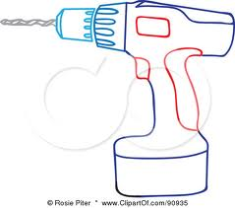

Above Tools as needed

Ladder

Tape

Flat Blade screwdriver

Pencil

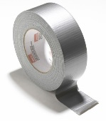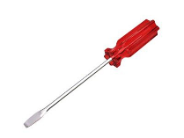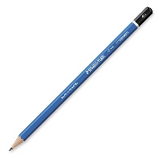

Phillips screwdriver

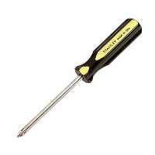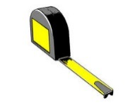

A

B

C

D



E

***********************************************************************************************WARNING! This operator system is equipped with an unattended operation feature.

The door could move unexpectedly.

***********************************************************************************************

This device has been designed and tested with SAFETY as the first priority. Current garage door operators generally are used when the user[s] have a line-of-sight to the garage door. It is important that all the users and persons traveling through the garage space have knowledge of the operation of this device.

* DO NOT install on one-piece or swinging doors.
* This product is designed for use on residential sectional doors ONLY.
* For use only with on garage door operators complying with UL325, manufactured after Jan 1, 1993 that utilize photoelectric SAFETY sensors. Any modifications may cause serious injury.
* DO NOT block the LED lights or disable the audible warning beeper.
* Please familiarize all persons that may use the garage door operator of this devices operation.
* The SRG232 uses a ‘screw on’ antenna, this antenna receives and transmits Cellular signals. Consider the cellular signal strength when installing the SRG232 control module. A mobile device (cellphone) strength meter can be used to check the garage space for best signal. When mounting, position the module with the antenna pointing UP. Note: The cellular signal utilizes SPRINT™ as the carrier. The Bluetooth™ signal antenna is internal to the SRG232.
* The SRG232 has a flashing strobe LED, an audible beeper, and a WARNING label. The LED flashes and the audible beeper activates when the SRG232 receives a CLOSE signal from a mobile device running the SecuRemote™ application. Mount the SRG232 device in a visible location. Adjacent to the ‘doorbell’ button or console makes an ideal location. In the event the door is closing and needs to stop, press the ‘doorbell’ button to cancel the motion. Place the supplied WARNING label in a visible location near the ‘doorbell’ button.

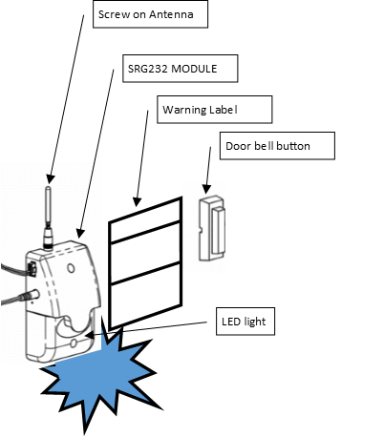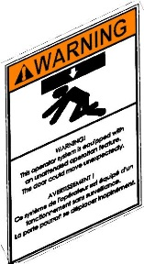

Flashing Strobe LED

## Install SR GDO

TURN ALL POWER **OFF** TO GARAGE DOOR OPERATOR BEFORE ATTEMPTING INSTALLATION

The module and sensor performs two functions:

1. The SR GDO activates the console or Garage OPEN/CLOSE “doorbell” button.

Close up of Garage Door Operator connection. Refer to ***Current*** operator instructions for detail connections.

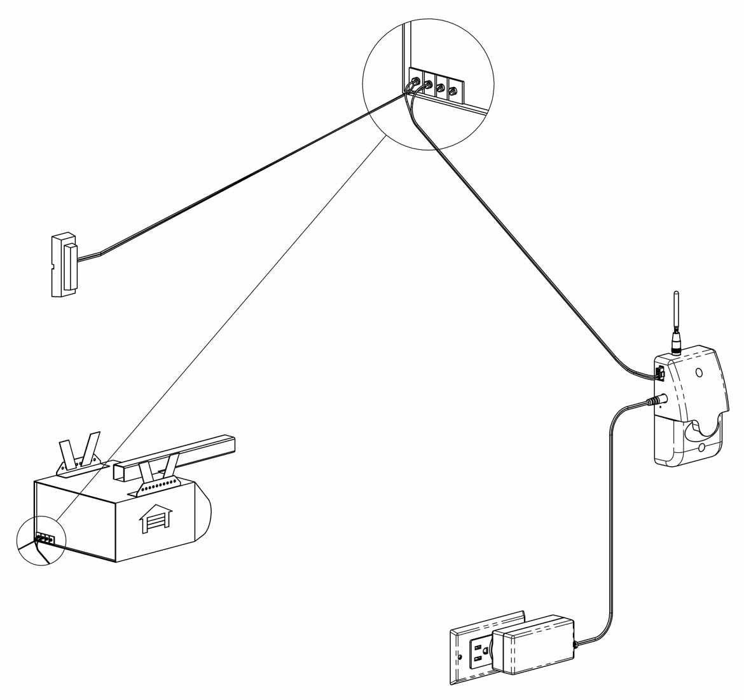

Mount the SRG232 module with screws as shown. For safety purposes, Place the module where it is visible to persons inside the garage area.

QR and ID labels on back of module. See instructions for use details.

Install user WARNING label

Reset button. Use paperclip ONLY. ALL USERS WILL BE ERASED See Section 7

**New** Control wire to SRG232

**New** SRG232 module.

Align Antenna as shown.

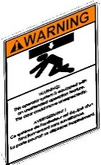

***New*** Wire to Sensor See Section 2)

C

D

D

***Current*** “OPEN/CLOSE button

**New** Plug-in power supply use 110V A/C outlet

**New** Power supply wire to SRG232

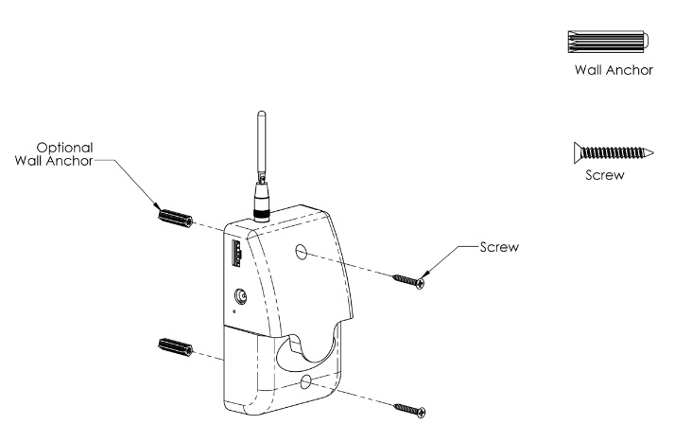

***Current*** Garage Door Operator.

1. The SENSOR will monitor the garage door position. Note: The location marker sensor uses a rare earth permanent magnet. Please place this sensor carefully as shown. [ place location marker sensor within ¾” and no further than 2 ¼” from the magnet on the top of the door. The SRG232 Module uses this sensor assy to report and control the door OPEN/CLOSE operations.

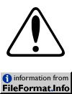

******* DO NOT ATTEMPT TO OPERATE THE DOOR WITHOUT THE SENSOR. *******

The sensor wire shares the control wire ‘plug’ that snaps into the SRG232 module. The wire leads may be attached either way to sensor. The wire length should be considered when installing the SRG232 module placement. Avoid placing wire across the wheel tracks of the garage door.

***New*** If wire needs to be shorter, cut and strip wire, CONNECT TO LOCATION SENSOR

***New*** Wire to module

See Section 1)

B

E

D

A

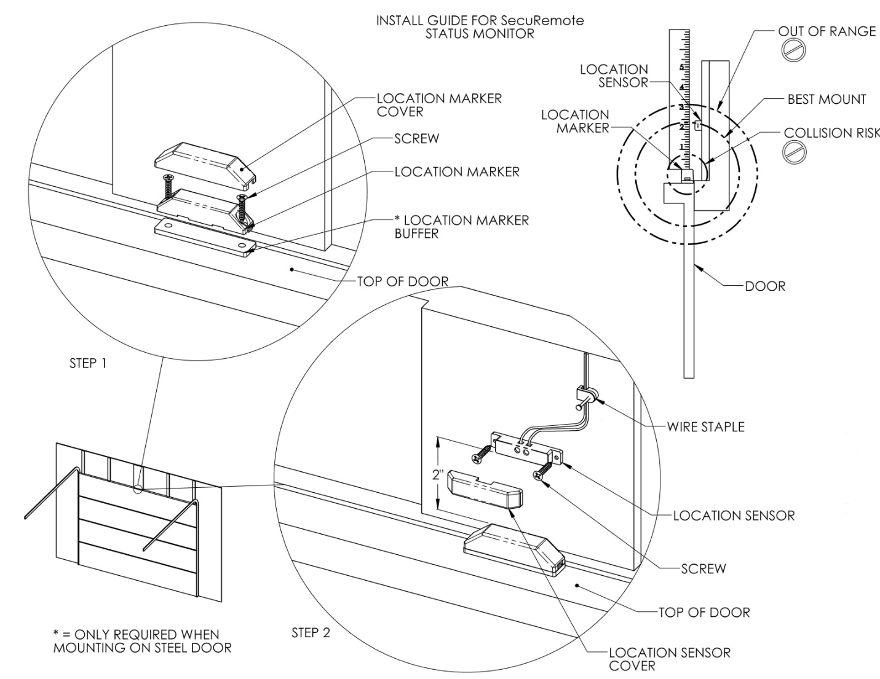

## SR GDO detail for different buttons and LED’s

* **LED Indication**
* **Blue** **LED** – Blinks when smartphone is connected to SR GDO
* **Red** **LED** – Glows as door close
* **Green LED** – Glows as door open

# Symbol Explanations for SR GDO

|  |  |
| --- | --- |
|  | The SR Smart App is performing an operation |
|  | Press this button to check the status of the selected device |
|  | The device is in “Opened” position |
|  | The device is in “Closed” position |

# SR GDO Overview

SR GDO represents a new era of user-friendly security, control and convenience. It will provide many smart features that are not possible with standard conventional garage opener. Here is list of key features that is provided by this SR GDO.

* 1. Operate SR SR GDO using SR Smart application installed in iOS or Android devices. User can operate it within radius of up to 80 feet from SR GDO without obstacles in Local Mode.
  2. User can operate device from remote location.
  3. User can operate device by Keyfob within 40 feet range of device.
  4. Provide access to other users.
  5. Notification alert which is triggered if you have forget to close Garage door and moved a mile away from the SR device location.
  6. Audit trail shows last 255 operations in smartphone with detail about each operation executed by any user.
  7. Configure user PIN so it prompts user to enter PIN every time user operates SR GDO.
  8. User can upgrade firmware from SR Smart app.
  9. User can manage other user and device access settings from SecuRemote® Portal.

**How it works**

SR Smart™ app uses unique technology to transparently deliver powerful communication, authentication and functionality. The communication process begins when the primary User pairs his/her smartphone with a SecuRemote® device. The device registers the first users as an “Administrator”.

The Administrator can add 10 users (total of 10 users including Administrator/Keyfob) from his/her smartphone. Each user will receive a text Message with a link to download the App. Users can operate device within range of 80 feet in Local Mode depends on obstacle and Remote Location also.

## Local Mode

In this mode the communication between an SR device and a Smartphone is direct (between the two devices) using Bluetooth. Communication distance can be up to 80 feet depending on communication obstructions or the product application. This mode also supports Administration (Users are stored on the device itself), and Notification within Bluetooth range.

## Remote Mode

This mode offers all the previous benefits but it also adds the ability for an SR device to be connected to UDI online portal all the time thus allowing a remote operation through UDI online portal and event monitoring even when a user’s Smartphone is not present. This mode requires the connectivity with SR Portal. The SR SR GDO has CDMA connectivity inside which makes setup and configuration automatic. The SR GDO uses SR Protocol to connect automatically with up to 24 SR devices wireless and directs the messaging to the UDI online portal.

# Download SR Smart App for iOS

The SR Smart App will operate any SR GDO. Upon selecting the SR GDO user wants to operate the app will automatically display menu features and functionality for selected device. The app is available for download through the App Store on your Smartphone. Search for "SR Smart" or “SecuRemote® Smart” word. User should always download the SR Smart App directly from your smartphone’s store as this practice ensures future automatic app improvements/updates.

***Note:*** Make sure smartphone have the data connectivity to download app.

## Download the SR Smart App through App StoreSM

1. Click on “App Store Icon” to open app store. Refer Figure 1.
2. Search “SR Smart” keyword to find SR Smart™ application. Refer Figure 2.
3. Click on “FREE” it will prompt for an apple ID and password to begin SR Smart application download. Refer Figure 3.

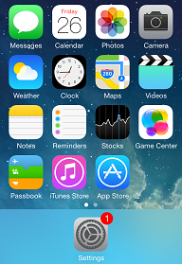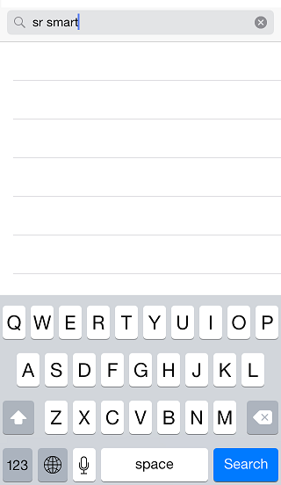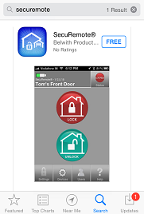

Figure 1: Smartphone Home Screen Figure 2: Search for SR Smart App Figure 3: App store search Screen

1. Click on “INSTALL”, to start installation of SR Smart application. Refer Figure 4.
2. By default, the “SR Smart™ App icon” will be placed in the first available spot on your home screen. Refer Figure 5.

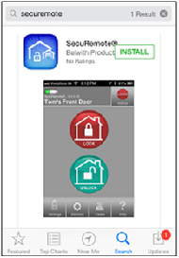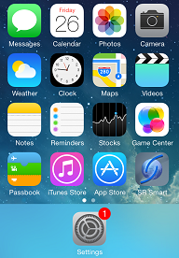

Figure 4: Installation Screen Figure 5: App Icon in Home Screen

# Download SR Smart app for Android

The SR Smart App will operate any SR GDO. Upon selecting the SR GDO user wants to operate the app will automatically display menu features and functionality for selected device. The app is available for download through the Google Play Store on your Smartphone. Search for "SR Smart" or “SecuRemote® Smart” word. User should always download the SR Smart App directly from your smartphone store as this practice ensures future automatic app improvements/updates.

***Note:*** Make sure smartphone have the data connectivity to download app.

## Download the SR Smart App through Play StoreSM

1. Click on “Play Store” icon to download SR App. Refer Figure 6
2. Search “SR Smart” keyword to find Securemote® Smart application. Refer Figure 7.
3. Click on “FREE” to begin SR Smart application download. Refer Figure 8.

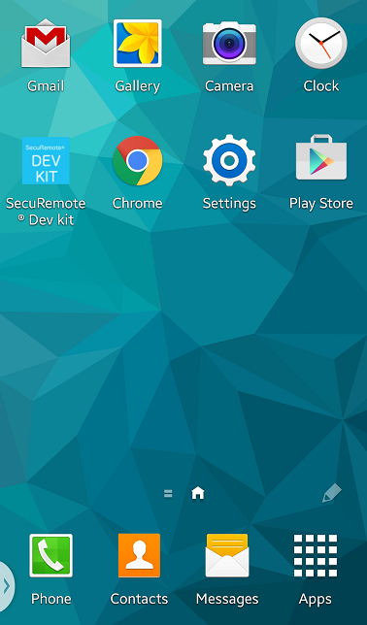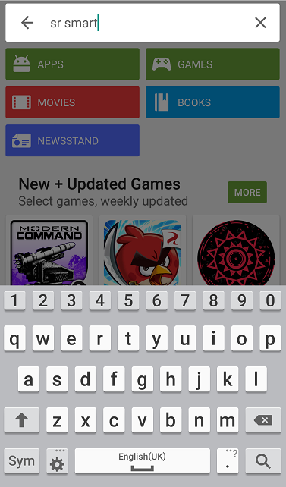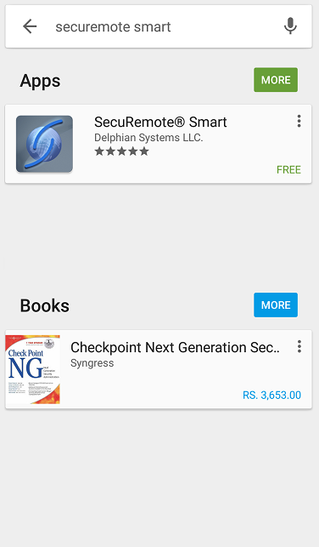

Figure 6: Smartphone Home Screen Figure 7: Search App Figure 8: App store search Screen

1. Click on “INSTALL”, to start installation of SR application. Refer Figure 9 .
2. By default, the “SR Smart™ App icon” is placed in the first available spot on your home screen. Refer Figure 10.

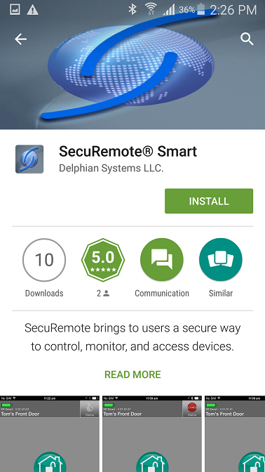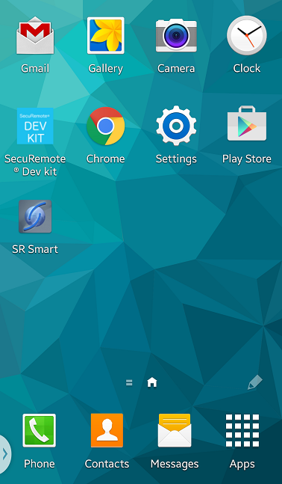

Figure 9: Install SR Smart App Figure 10: Installation Completed

# Register Device and Operate SR GDO

After successful installation of “SR Smart” app, SR Smart app icon will appear on smartphone home screen. User can register SR device using “Scan QR Code” or “Enter Sr# manually” options, upon successful activation user can pair and operate SR GDO.

**Note:** Make sure Data & Bluetooth connectivity is “ON”.

## Register Device using Scan “QR Code”

1. Click on the “SR Smart” app icon to launch the SR Smart app. “ADD SR DEVICE” screen will open. Refer Figure 11.
2. Click on “Scan QR Code” option to add device, “Scan QR Code” will launch Camera to scan SR # from user manual or interior part of SR GDO. Refer Figure 12 .
3. After QR Code is scanned successfully, SR Device information fill automatically in “ADD SR DEVICE” screen. Enter “SR Device Name” and click on “Create New Account” option. Refer Figure 13.

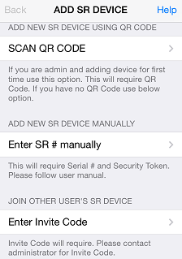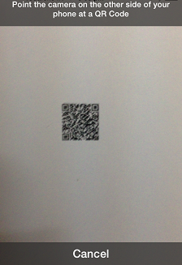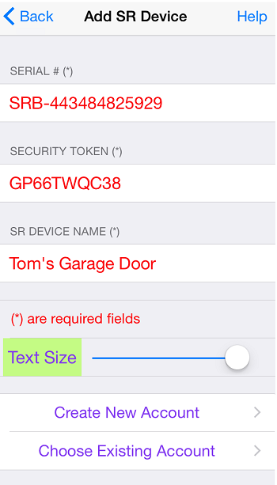

Figure 11: Add SR Device Figure 12: Scan QR Code Figure 13: Add SR Device

1. Enter all mandatory information in “Create SR Account” screen and click on “Register SR Device” option. Refer Figure 14.
2. It will display “Registering SR Device” activity message in “Create SR Account” screen. Refer Figure 15.
3. After device is registered on server it will redirect to app home screen and display “Garage is paired successfully, you can start operate it.” Toast message. Refer Figure 16.

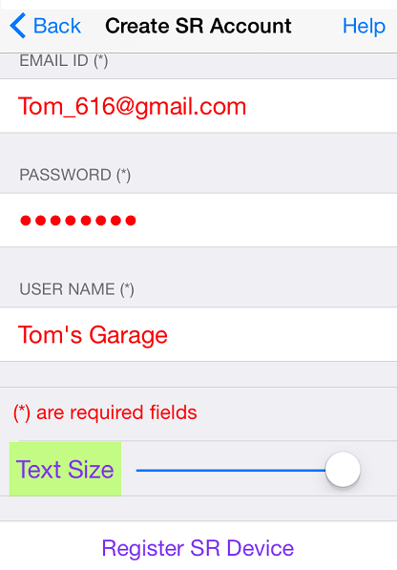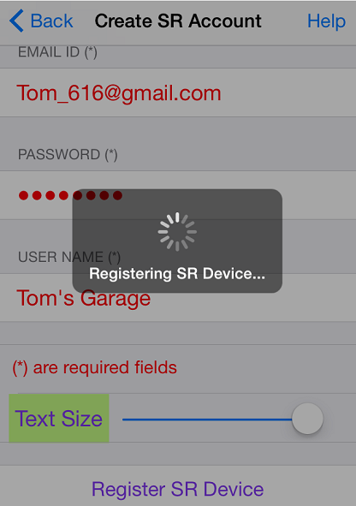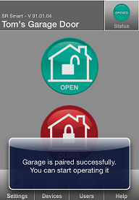

Figure 14: Create SR Account Figure 15: Registering SR Device Figure 16: Home Screen

## Register Device manually

1. Click on the “SR Smart” app icon to launch the SR Smart app. “ADD SR DEVICE” screen will open, Click on “Enter SR # manually” option to add device manually. Refer Figure 17.
2. It will display “ADD SR DEVICE” screen. Refer Figure 18.
3. Enter all require SR Device information and click on “Create New Account” or “Choose Existing Account” option to add SR Device information. Refer Figure 19.

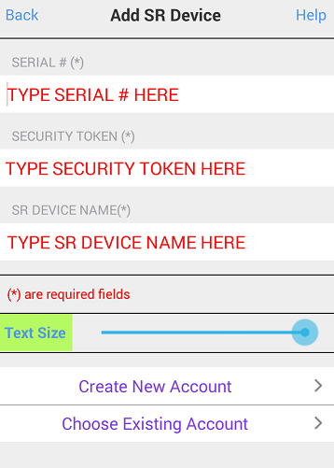

Figure 17: Add SR Device Figure 18: Add SR Device Figure 19: Add SR Device detail

1. It will display “Create SR Account” screen. Refer Figure 20.
2. Enter all require SR Account details and click on “Registering SR Device” option, it will appear “Registering SR Device” activation message. Refer Figure 21
3. After device is registered on server it will redirect to app home screen and display “Garage is paired successfully, you can start operate it.” Toast message. Refer Figure 22.

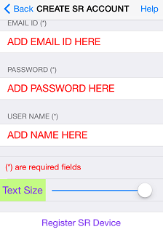

Figure 20: Create SR Account Figure 21: Registering SR Device Figure 22: Home Screen

# Operate SR GDO using SR Smart App

1. Device Home Screen when device is not connected. Refer Figure 23.
2. Click on the “Close” button to close the Door, it will display “Door is Closed” toast message. Refer Figure 24.
3. Click on the “Open” button to open the Door, it will display “Door is opened” toast message. Refer Figure 25.

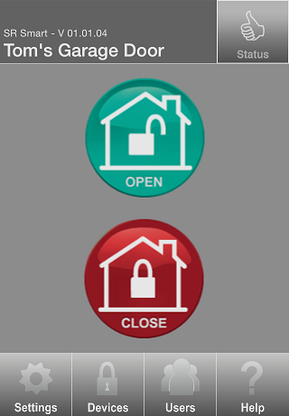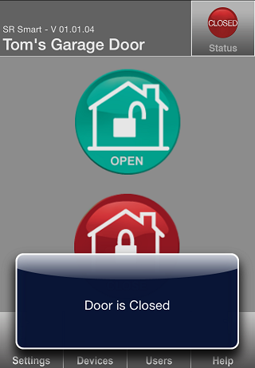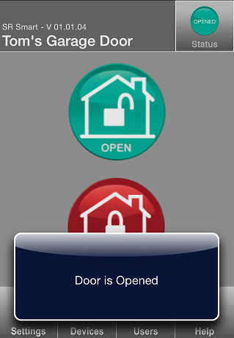

Figure 23: Home Screen Figure 24: Closed Message Figure 25: Opened Message

# Check Status of your SR GDO

1. If the door is opened then “Opened” will be indicated in Status. Refer Figure 26.
2. If the door is closed then “Closed” will be indicated in Status. Refer Figure 27.

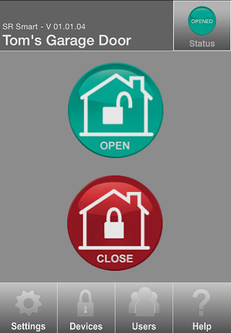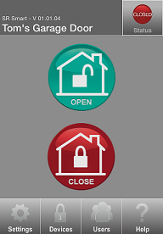

Figure 26: Opened Status Figure 27: Closed Status

# Setting Management

Admin user can set any SR GDO parameter using this option. Go in “SR Device Settings” from “Settings” option to change settings.

## SR Device Settings

1. Click on “Settings” from Home screen and click on “SR Device Settings” option. Refer Figure 28.
2. It will display “Admin PIN” Screen, enter “Admin PIN”. Refer Figure 29.
3. It will display “SR Device Settings” screen. Refer Figure 30.

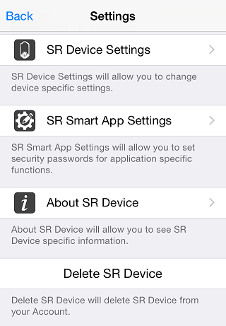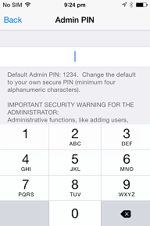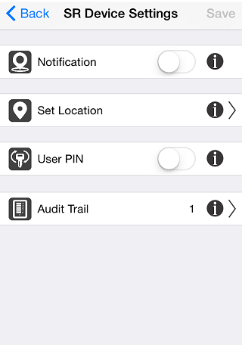

Figure 28: Settings Screen Figure 29: Admin PIN Figure 30: SR Device Settings

**Note:**After change all the settings click on “Save” option to change settings.

## Notification

Notification alert which is triggered if you have forget to close Garage door and moved a mile away from the SR device location. This is accomplished by SR tracking both the SR device status and your approximate location by using your smartphone's Location Services.

1. Click on SR Device Settings it will display SR Device Settings screen. Refer **Figure 31**.
2. Enable “Notification” and click on “SAVE” button. Refer **Figure 32**
3. Notification message will display in smartphone notification screen. Refer **Figure 33**

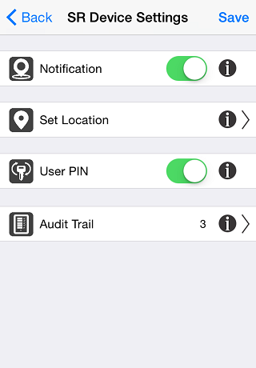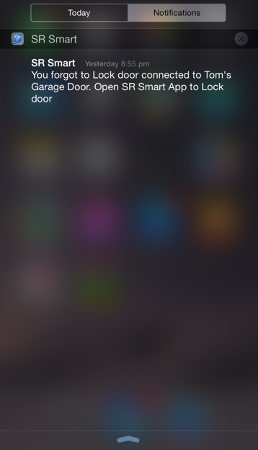

Figure 31: SR Device Settings Figure 32: SR Device Settings Figure 33: Notification

## Set Location

This feature is used to set the Current Location of your SR GDO, which is necessary to enable “Notification” feature of SR GDO.

1. Click on “Set Location” option and make sure your smartphone is at a location closest to the SR GDO. Refer Figure 34.
2. Location Settings Screen will appear, click on “Set Location” option. Refer Figure 35.
3. Set Location Message will pop up with “cancel” and “Set Location” options, Click on “Set Location”. Refer Figure 36.

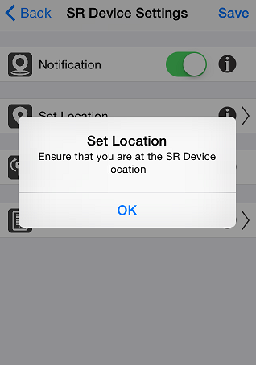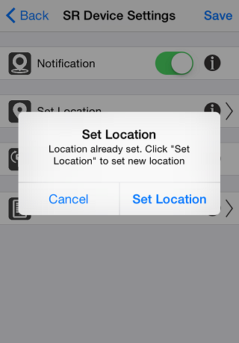

Figure 34: SR Device Settings Figure 35: Location Settings Screen Figure 36: Set Location Message

1. It will display “fetching current location” message. Refer Figure 37.
2. It will display “Device Location is set successfully. Region monitoring is enabled” message with “OK” Button. Refer Figure 38.

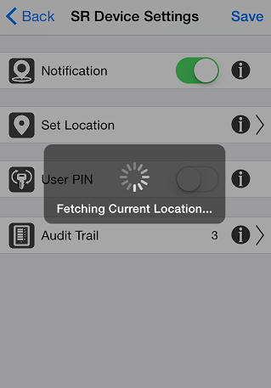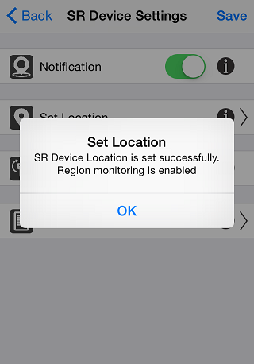

Figure 37: Location Settings Message  Figure 38: Set Location Message

## User Pin

Configure user PIN so it prompts user to enter PIN every time user operates SR GDO.

This feature is used to Enable/Disable User Pin.

1. Click on SR Device Settings it will display SR Device Settings screen. Refer **Figure 39**.
2. Enable User PIN. Refer **Figure 40**.



**Figure 39: SR Device Settings** **Figure 40**: **SR Device Settings**

**Note:**After change User Pin settings click on “Save” option to change settings.

## Audit Trail

This option records and displays the last 255 operations performed.

Each entry has following details:

* Time, Date and Day
* Type
* Status
* User Name

For operations performed via the Smart Button or Keyfob, the Time, Date and Day will not be available. “Keyfob” will display as User name. Refer Figure 41.

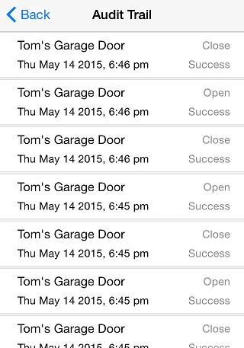

Figure 41: Audit Trail

## SR App Settings

This option lets user change the default SR App Settings.

1. Click on “Settings” option from Home screen. Refer Figure 42.
2. It will display “SR GDO” setting Screen, Click on “SR App Settings” option. Refer Figure 43.
3. It will Display “SR App Settings” screen. Refer Figure 44

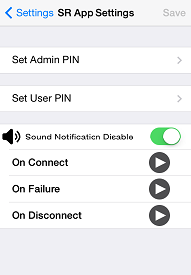

Figure 42: Home Screen Figure 43: Settings Screen Figure 44: SR App Settings

## Set Admin PIN

This option allows the user to change the Admin PIN. Admin PIN must be at least four numeric characters and default value is “1234”.

1. Click on “Set Admin PIN” from SR App Settings screen. Refer Figure 45.
2. It will prompt existing “Admin PIN”; enter default “1234” as admin PIN. Refer Figure 46.
3. Admin PIN screen display. Refer Figure 47.

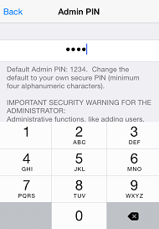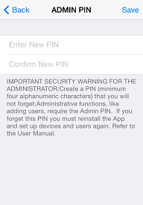

Figure 45: SR App Settings Figure 46: Admin PIN Figure 47: Admin PIN

1. Enter “New Admin PIN”, “Confirm PIN” and click on “Save” button. Refer Figure 48.
2. It will display “Admin PIN changed successfully” toast message. Refer Figure 49.

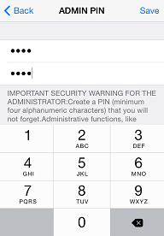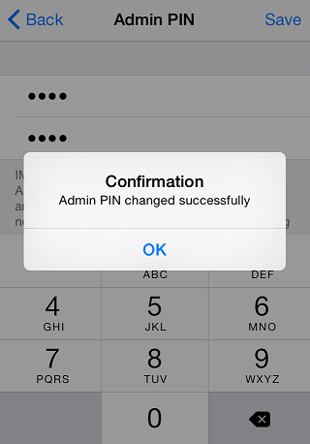

Figure 48: Admin PIN Figure 49: Success Message

**Note:** In order to change Admin PIN, user must know current Admin PIN. Default Admin PIN is “1234”. Admin Pin is stored to smartphone so each user with Admin privilege can set any four alphanumeric characters as Admin PIN. If the user forgets the Admin PIN, user needs to re-install the SR Smart™ application.

## Set User PIN

This option allows the user to change the User PIN. The User PIN is a minimum of four alphanumeric characters and provides additional security. The Admin can force new users to use the User PIN. If enabled, the User PIN must be entered every time this user initiates the unlock operation. Only Admin can disable User PIN for any user.

1. Click on “Set User PIN” from SR App Settings screen. Refer Figure 50.
2. It will prompt existing “User PIN”; enter default “1234” as User PIN. Refer Figure 51.
3. User PIN screen will display. Refer Figure 52

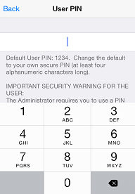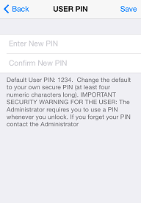

Figure 50: SR App Settings Figure 51: User PIN Figure 52: User PIN

1. Enter “New PIN”, “Confirm New PIN” and click on “Save” button. Refer Figure 53

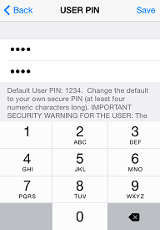

Figure 53: User PIN

**Note:** In order to change User PIN, user must know current User PIN. Default User Pin is “1234”. User PIN is stored to smartphone so each user can set any User PIN. If the user forgets the User Pin, user needs to reinstall the SecuRemote® BLE application.

## Sound Notification

The SR App plays different sounds upon Connecting, Disconnecting and any failure event. User can enable/disable this setting.

1. Click to disable Sound Notification. Refer Figure 54.
2. Sound Notification is disabled. Refer Figure 55.

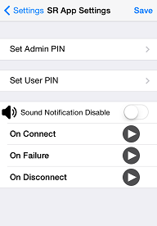

Figure 54: SR App Settings Figure 55: SR App Settings

## About SR Device

It provides details on Manufacturer’s Name, Model Number, Hardware Version and Software Version of the SR GDO.

1. Click on “Settings” from Home screen and click on “About SR Device”. Refer Figure 56.
2. It will open “About SR Device” Screen with SR GDO details. Refer Figure 57.

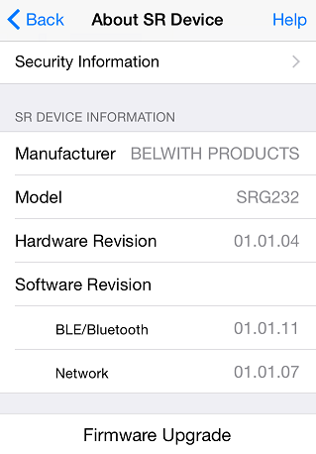

Figure 56: Settings Screen  Figure 57: About SR Device

## Firmware Upgrade

Using this feature user can upgrade Firmware from SR App over the Air (OTA).

1. Click on “Settings” from Home screen and click on “About SR Device” option. Refer Figure 58.
2. It will display “Admin PIN” Screen, enter “Admin PIN”. Refer Figure 59.
3. It will display “Please select firmware file from mail having .bin (For iOS) or .hex(For Android) extension and then select open with SR Smart application option“ message with “ok” button. Refer Figure 60.

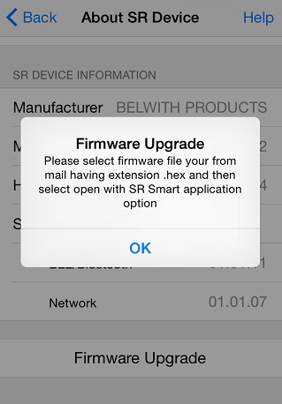

Figure 58: About SR Device Screen Figure 59:  Admin PIN Figure 60: Firmware Upgrade Message

1. Open email and click on .bin file to select application. Refer Figure 61.
2. Select “Open in SecuRemote®” to open firmware upload screen. Refer Figure 62.
3. Press “Upload Firmware” to start uploading firmware. Refer Figure 63.

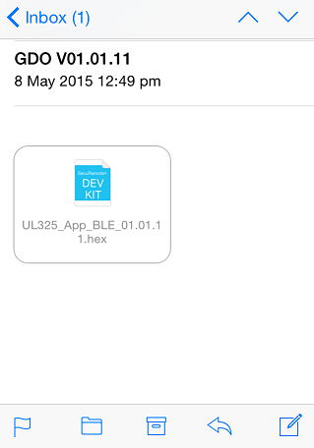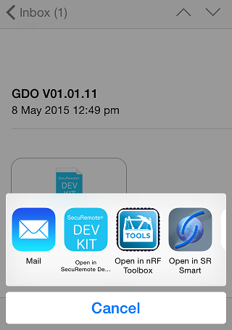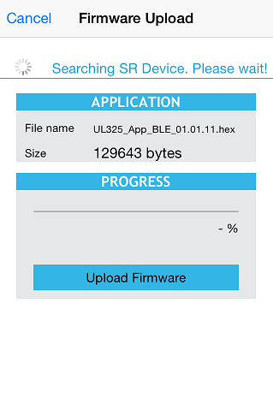

Figure 61: Mail Inbox Figure 62: Select App Figure 63: Firmware Upload Screen

1. Wait for Complete 100% progress bar. Refer Figure 64.
2. Firmware “Finished upload” message will be displayed with “OK” button. Refer Figure 65.

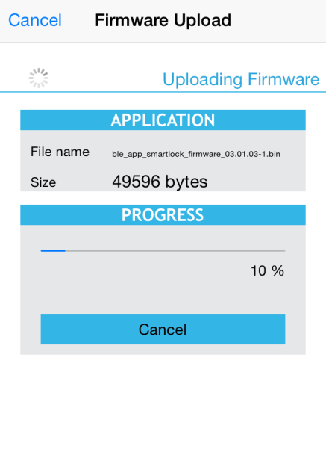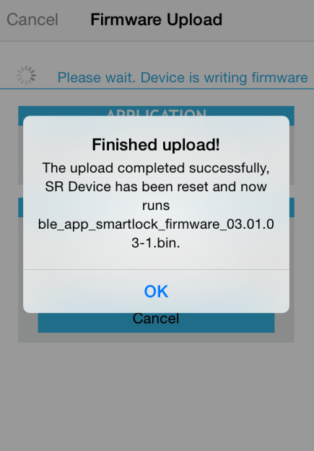

Figure 64: Uploading Firmware Figure 65: Finished Uploaded Message

# Device Management

The user can click on “Devices” option from SR Smart App Home Screen to display, add, delete, rename or check status of all installed SR GDO controlled by this iOS/Android device.

## Add Device

To add new device user can use this option.

1. Select Devices option from Home Screen. Refer **Figure 66**.
2. Click on Add SR Device to add new device. Refer **Figure 67**.
3. In Add SR Device user can add device using available options. Refer **Figure 68**

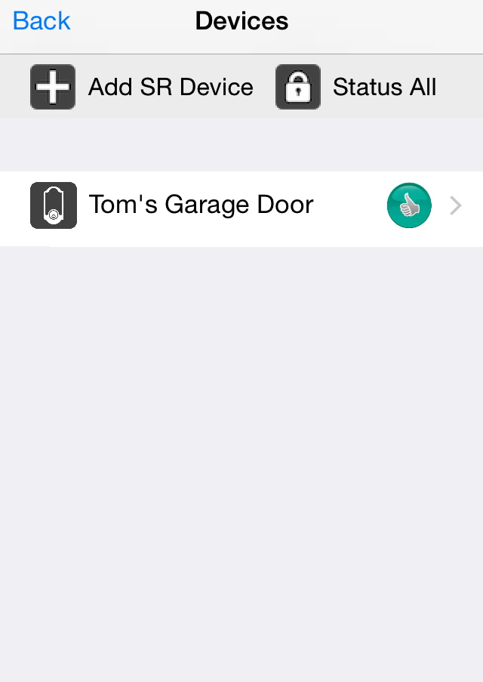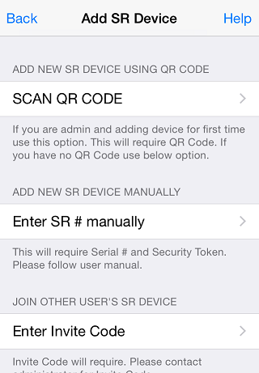

**Figure 66:** **Home Screen** **Figure 67:Device Screen** **Figure 68: Add Device Screen**

## Rename Device

In this option use can change Device name.

1. From Home Screen select existing name of the device. Refer **Figure 69**.
2. It will redirect to SR Device Name screen and provide new name. Refer **Figure 70**.
3. Click on “Save” button and it will change new name. Refer **Figure 71**.

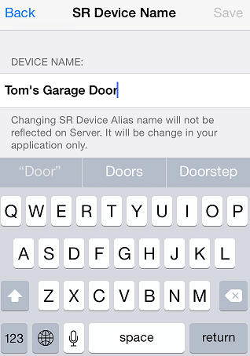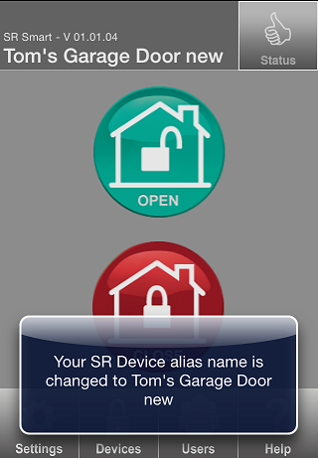

**Figure 69: Home Screen** **Figure 70:SR Device Name Screen** **Figure 71: Name Changed Screen**

## Delete Device

The Admin user only can delete any SR GDO Device by clicking on “Delete SR Device” option from “Settings” screen. Click on “Delete SR Device” button to delete that device. Confirm the action by clicking on Yes to complete the process:

**Note:** This option is only available for Admin

1. Click on Settings from home screen. **Figure 72**.
2. Click on Delete SR Device. Refer **Figure 73**.
3. It will ask user to enter Administrator Details. Refer **Figure 74**.

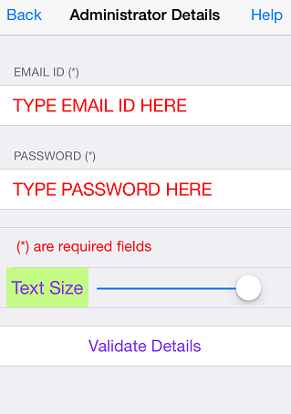

**Figure 72: Home Screen** **Figure 73:Settings Screen** **Figure 74:Administrator Details**

1. Enter Proper Details and click on Validate Details screen. Refer **Figure 75**It shows Removing SR Device. Refer **Figure 76**.
2. After Removing SR Device it will redirect to Add SR Device Screen. Refer **Figure 77**.

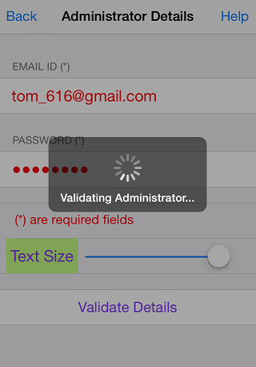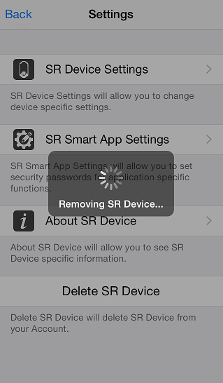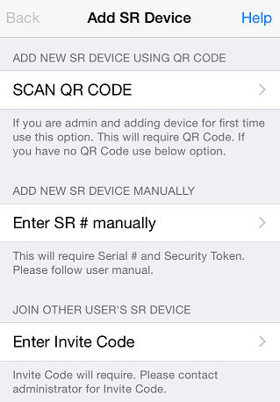

**Figure 75: Administrator Details** **Figure 76: Removing SR Device** **Figure 77: Add SR Device Screen**

## Status All

This option lets user retrieve the current status of all connected SR Devices managed by this application.

1. Click on Devices Screen. Refer **Figure 78**
2. Click on Status All. Refer **Figure 79**.
3. It will show status of all devices. Refer **Figure 80**.

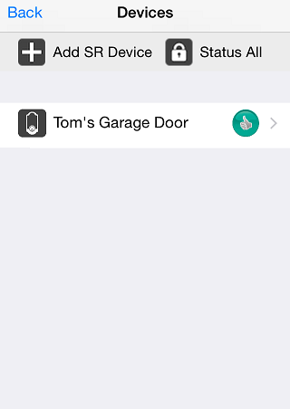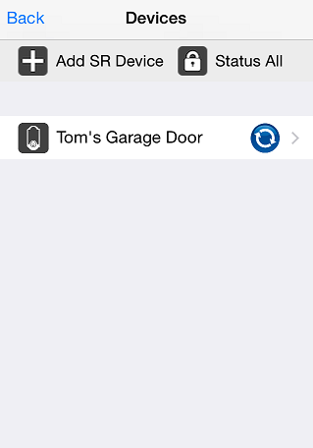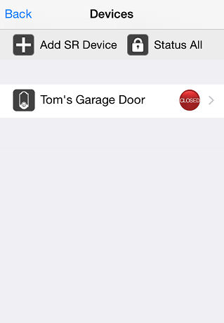

**Figure 78: Devices Screen** **Figure 79: Devices Screen** **Figure 80: Devices Status Screen**

## 

## Switching between devices

To switch between SR GDO, the user must go to the “Devices” menu at the bottom of the SecuRemote® App home screen. All managed SR Devices will be displayed, and the user can select the SR Devices they want to operate.

**Example:** The user is added with two SR device GDO “Tom’s Garage Door” and “RAS” devic. To operate “Tom’s Garage Door,” the user selects that name from the listed devices. The selected SR GDO’s Home screen will appear on the home screen of the SR Smart® app.

1. Click on “Devices” from Home screen. Refer Figure 81 .
2. Select Device from “Devices” screen. Refer Figure 82.
3. It will display selected device’s “Home” screen. Refer Figure 83.

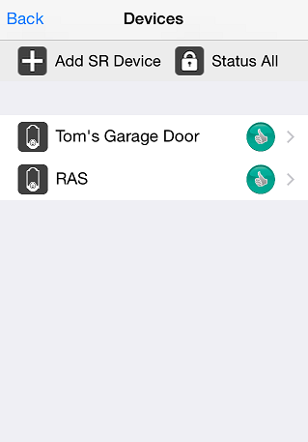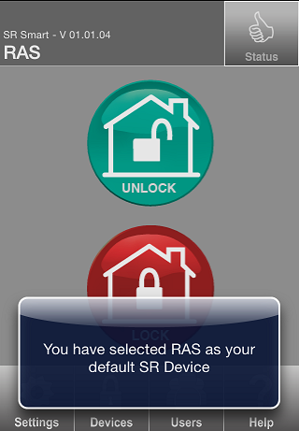

Figure 81: Home Screen Figure 82: Devices Screen Figure 83: Change Home Screen

# Users Management

User List provides the following functionality for each selected user:

* Add/Delete users
* Send SMS and Email to a User

This option allows the admin to invite, delete user. Access to this option is protected through the Admin PIN.

**Once invited, the Admin can share the Invite Code with the new user through: Email or SMS**

|  |  |
| --- | --- |
| Email | This option will sent email with new invite code using email address provided for the new user. The new user then enters this Code and serial number of the SR GDO when this new user installs and launches the SR Smart BLE Application and tries to pair with the SR GDO device. |
| SMS | This option will sent SMS with new invite code using phone number provided for the new user. The new user then enters this Code and serial number of the SR GDO when this new user installs and launches the SR Smart BLE Application and tries to pair with the SR GDO device. |

## 

## Add User

## Add User from Contact Book

The Admin can invite other users by clicking > ‘Invite User’ on the Users screen. Choose the invitee from the Contacts list, or enter the invitee’s name, email address, and mobile number. Next, choose the access type. Finally, click “Get Invite Code” to generate the invitee’s access code.

1. Click on “Users” from Home Screen. Refer Figure 84.
2. It will prompt for “Admin PIN”. Refer Figure 85.
3. Enter admin PIN to display “Access Devices” screen. Refer Figure 86.

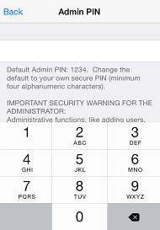

Figure 84: Home Screen Figure 85: Admin PIN Screen Figure 86: Input Admin PIN

1. It will display “Access Devices” Screen with “Invite User” and “Add Keyfob” options. Click on “Invite User”. Refer Figure 87.
2. It will display “Administrator Details” Screen for user validation. Refer Figure 88
3. Enter Administrator “EMAIL ID” and “PASSWORD” and click on “Validate Details”. Refer Figure 89.

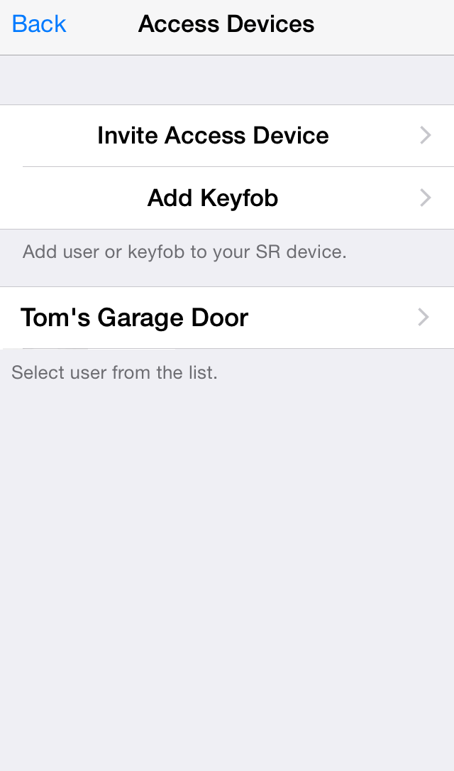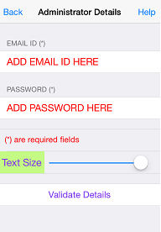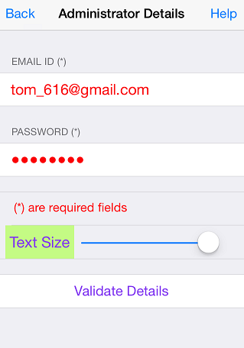

Figure 87: Access Devices Screen Figure 88: Admin Validation Screen Figure 89: Admin Validation Screen

1. It will display “Validating Administrator” ‘activity message ‘. Refer Figure 90.
2. It will display “Invite Users” screen with an option to select from Contacts and Field to enter user name. It also displays options to send User alert via email or SMS for the selected user. Click on “Select from contacts”. Refer Figure 91.
3. Phone Contact list will appear. Select any contact from list. Refer Figure 92.

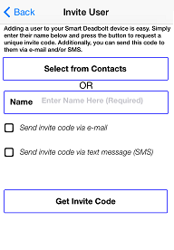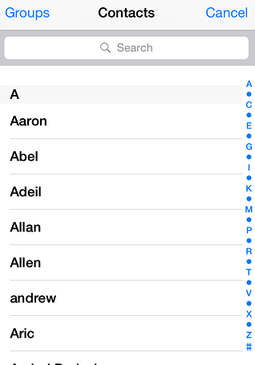

Figure 90: Admin Validate Message Figure 91: Phone contact Book Figure 92: Invite User Screen

1. It will display selected contact from the contact list. Click on contact number. Refer Figure 93.
2. It will display “Invite User” screen with option to send User alert via email or SMS. It will also display Authorization setting for the selected user. Refer Figure 94
3. Click on Check boxes and fill mandatory information then click on “Get Invite Code”. Refer Figure 95.

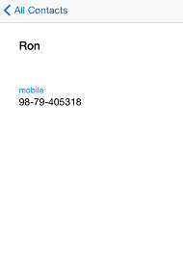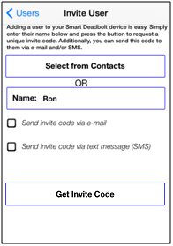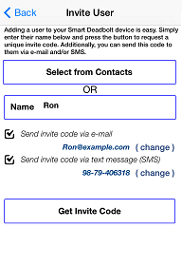

Figure 93: User Detail Figure 94: Invite User Screen Figure 95: Invite User Screen

1. It will display “Inviting User” activity message. Refer Figure 96.
2. Invite code is generated with a display message to “Notify User” through the chosen mode with “YES” and “NO” option. Click on “YES”. Refer Figure 97 .
3. It will display “User added” toast message in “Users” screen. Refer Figure 98.

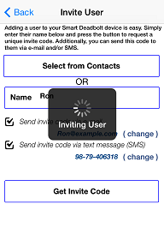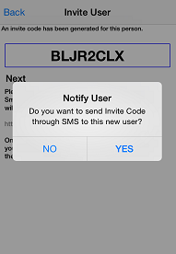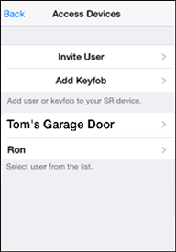

Figure 96: Inviting User Message Figure 97: Notify User Figure 98: Changed picture

**Note:** To add a user using phone’s contact list, click on ‘Select from Contacts’. The new user’s details will automatically appear, and the Admin can just click on ‘Get Invite Code’ to add that user to the users list.

## Add User Manually

1. Click on “Users” from Home Screen. Refer Figure 99.
2. It will prompt for “Admin PIN”. Refer Figure 100.
3. Enter admin PIN to display “Access Devices” screen. Refer Figure 101



Figure 99: Home Screen Figure 100: Admin PIN Screen Figure 101: Input Admin PIN

1. It will display “Access Devices” Screen with “Invite User” and “Add Keyfob” options. Refer Figure 102.
2. It will display “Administrator Details” Screen for user validation. Refer Figure 103.
3. Enter Administrator “EMAIL ID” and “PASSWORD” and click on “Validate Details”. Refer Figure 104.

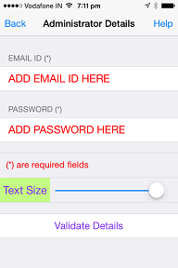

Figure 102: Users Screen Figure 103: Admin Validation Screen Figure 104: Admin Validation Screen

1. It will display “Validating Administrator” activity message. . Refer Figure 105.
2. It will display “Invite Users” screen. . Refer Figure 106.
3. Enter user name in “Name” Field, and select option to send User alert via email or SMS. . It will also display Authorization setting for the selected user. Refer Figure 107.

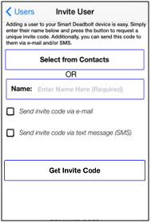

Figure 105: Admin Validate Message Figure 106: Invite user Screen Figure 107: Invite User Screen

1. Click on Check boxes and fill mandatory information then click on “Get Invite Code”. Refer Figure 108.
2. It will display “Inviting User” activity message. Refer Figure 109.
3. Invite code is generated with a display message to “Notify User” through the chosen mode with “YES” and “NO” option. Click on “YES”. Refer Figure 110.



Figure 108: Invite User Screen Figure 109: Inviting User Message Figure 110: Notify User Message

1. It will display “User added” toast message. Refer Figure 111.



Figure 111: changed picture

## About Access Device

The user with admin privilege and admin can modify settings of admin, using this option. Options include ‘Email Notification ’.

1. From “Access Device” screen click on “Ron“. Refer Figure 112.
2. It will display “Access Device” screen, Click on “About Access Device” option. Refer Figure 113.
3. It will display “About Device” with user’s Smartphone details. Refer Figure 114.

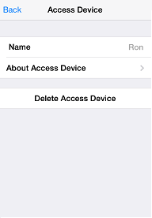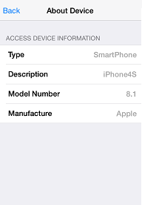

Figure 112: Access Device Screen Figure 113: Access Device Screen Figure 114: About Device Screen

## Delete Access Device

1. From “Access Device Screen” screen click on “Ron “. Refer Figure 115.
2. It will display “Access Device” screen with all the user options, click on “Delete Access Device”. Refer Figure 116.
3. It will display “Removing User” message with “Yes” and “No” button and Click on “Yes”. Click on “Yes”. Refer Figure 117.

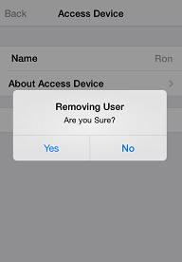

Figure 115: Access Device Screen Figure 116: Admin Screen Figure 117: Removing User

1. It will display “Removing User” activate message. Refer Figure 118.
2. It will display “Access Device “screen. Refer Figure 119.

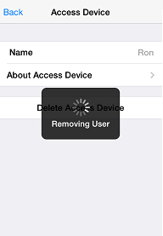

Figure 118: Removing User Message Figure 119: Access Device Screen

**Note:**  Tom’s Garage Door (Admin User) can’t delete himself.

## Keyfob

It allows the addition of a Keyfob as another user so it can operate the SR GDO, a SR GDO package may include one or more Keyfob. One Keyfob device can operate up to 4 Locks (SR GDO).

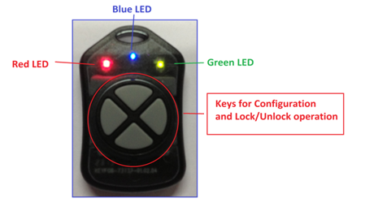

The Keyfob must be configured before it can be added as a user. To configure a Keyfob, the Smart phone and the Keyfob must be within radius of 20 feet from the Lock.

## Add Keyfob

1. Click on “Users” from Home Screen. Refer Figure 120.
2. It will prompt for “Admin PIN”. Refer Figure 121.
3. Enter admin PIN to display “Access Devices” screen. Refer Figure 122.



Figure 120: Home Screen Figure 121: Admin PIN Screen  Figure 122: Input Admin PIN

1. It will display “Access Devices” Screen with “Invite User” and “Add Keyfob” options. Click on “Invite Access Device”. Refer Figure 123.
2. It will display “Administrator Details” Screen for user validation. Refer Figure 124.
3. Enter Administrator “EMAIL ID” and “PASSWORD” and click on “Validate Details”. Refer Figure 125.



Figure 123: Users Screen Figure 124: Admin Validation Screen Figure 125: Admin Validation Screen

1. It will display “Validating Administrator” activity message. Figure 126.
2. It will prompt “Add Keyfob message” with “OK” button, click on “OK” button. Refer Figure 127.
3. It will display “searching for Keyfob” message along with “Red” and “Green” LED indication, Press and hold any Keyfob button for 5 seconds to configure Keyfob. Refer Figure 128.

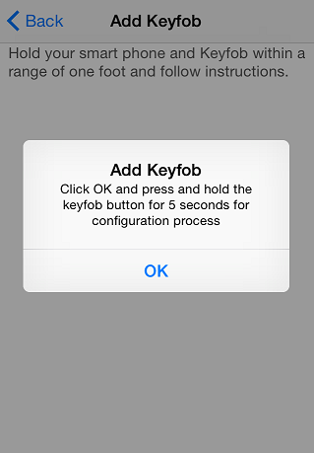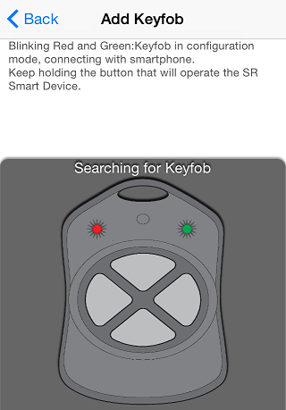

Figure 126: Admin Validate Message  Figure 127: Add Keyfob Figure 128: Searching Keyfob

1. When Keyfob is detected the SR GDO it will display a message “Configuring Keyfob, please wait” with “Blue LED” indication. Refer Figure 129.
2. Once configured, it will display “Keyfob button is configured” toast message. Refer Figure 130.
3. It will display a message “Keyfob activated to work with this SR GDO by pressing the button: Connecting - Blue LED, Unlocking – GREEN LED for 3 sec, Locking - RED LED for 3 seconds” with “OK” button. Refer Figure 131.

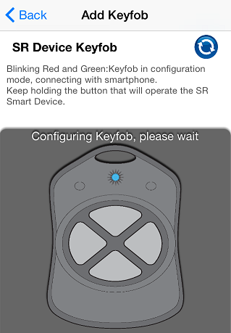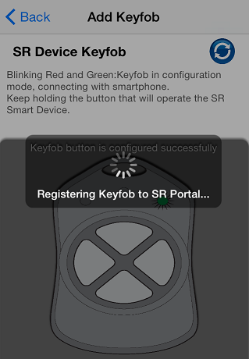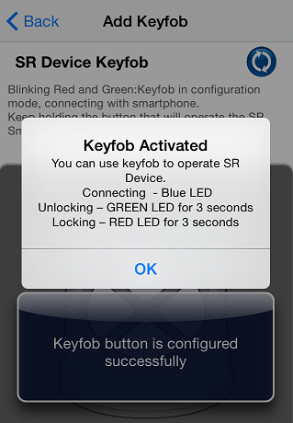

Figure 129: Keyfob Configuring Figure 130: Keyfob configured Figure 131: Keyfob button activated

## About Keyfob Device

1. From “Access Devices” screen click on “KEYFOB-96235634“. Refer Figure 132
2. It will display “Access Device” screen, Click on “About Access Device” option. Refer Figure 133.
3. It will display “About Device” with Keyfob’s details. Refer Figure 134.

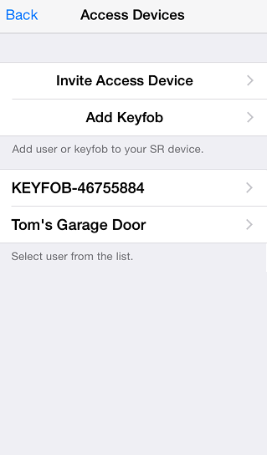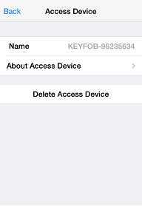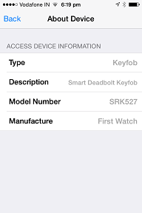

Figure 132: Access Devices Screen Figure 133: Access Device screen Figure 134: About Device Screen

## Delete Keyfob Device

1. From “Access Devices” screen click on “KEYFOB”. Refer Figure 135.
2. It will display “Access Device” screen with all the user options, click on “Delete Access Device”. Refer Figure 136.
3. It will display “Removing User” message with “Yes” and “No” button and Click on “Yes”. Refer Figure 137

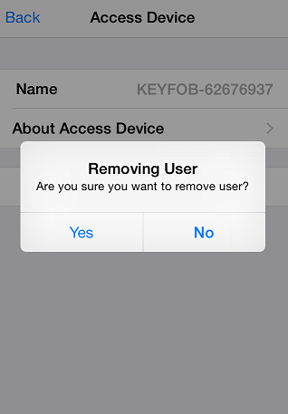

Figure 135: Access Device Screen Figure 136: Access Device screen Figure 137: Removing User screen

1. It will display “Removing User” activate message. Refer Figure 138.
2. After that it will redirect to the “Access Devices” screen. Refer Figure 139.

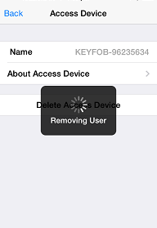

Figure 138: Removing User Message Figure 139: Access Devices Screen

# Help Option

In this option user can view “HELP” file and from developer option user can enable “Camera”:

* Help
* Developer Options

## Help

When user click on help option it shows help file to the user.

1. Click on Help option from home screen. Refer **Figure 140**
2. Click on Help from ‘ Information ‘ Screen Refer **Figure 141**
3. It shows Help file. Refer **Figure 142**

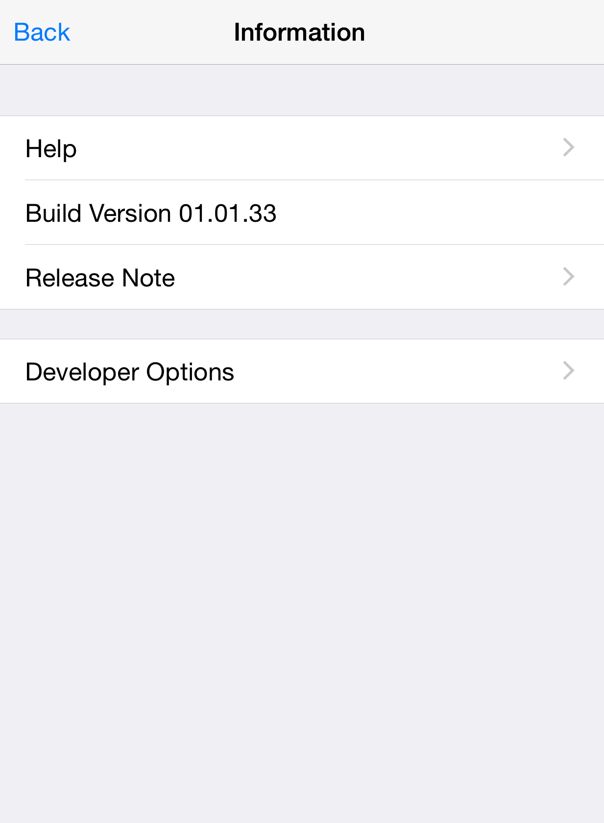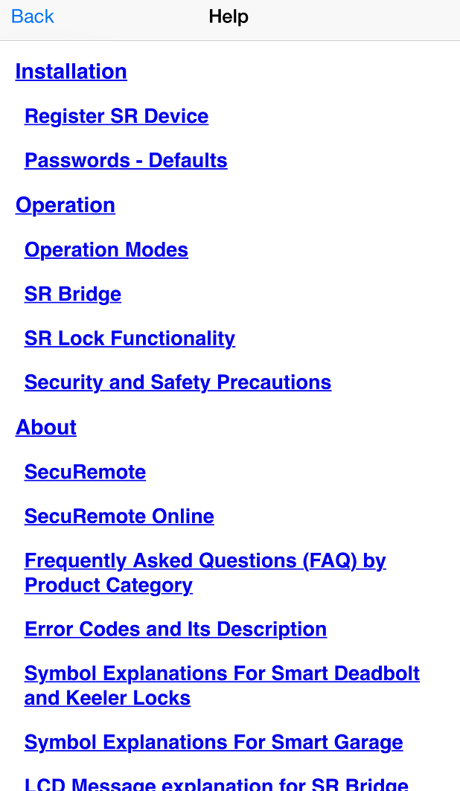

**Figure 140: Home Screen** **Figure 141: Information Screen** **Figure 142: Help Screen**

## Developer Options

**IP Camera support**

**Camera Type**

1. **D-Link: Following camera models are supported:**

* DCS-942L
* DCS-930L
* DCS-933L

1. **Foscam: Following camera models are supported:**

* FI8910W
* FI8918W

**Set up IP camera**

**Following Information will be required to Set Camera IP**

* Camera Type.
* Select camera model
* Enter external (WAN) IP address (Host)
* Enter port number
* Enter User name
* Enter Password

**External (WAN) IP address**

From PC or Phone which is connected to same router to which IP camera is connected, open browser and type.

**Steps to Enable IP camera**

Click on “Help” option to open “Help” screen. Refer Figure 143.

Help “Information” will appear, click on “Developer Options” and it will prompt for “Developer PIN”. Refer Figure 144.

Enter default PIN “123456” as Developer PIN. Refer Figure 145.

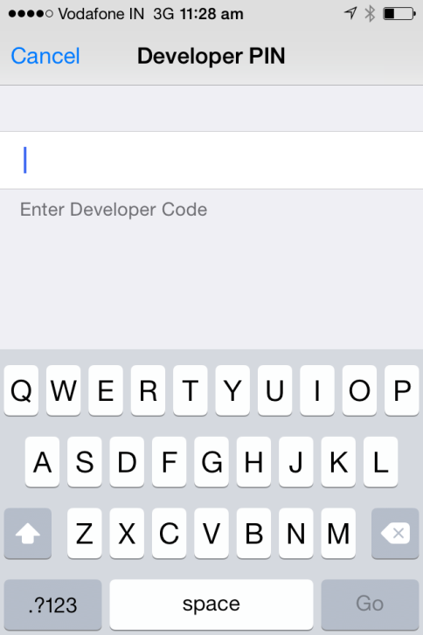

Figure 143: SR app Home Screen Figure 144: Help Screen Figure 145: Developer PIN Input Screen

It will display “Developer Options” screen, click on “Camera Settings”. Refer **Figure 146**.

Enable “Camera”, fill all mandatory information, “Save” the settings & return to the Home Screen. Refer **Figure 147**.

Camera picture will display in “SR App Home Screen”. Refer **Figure 148**.

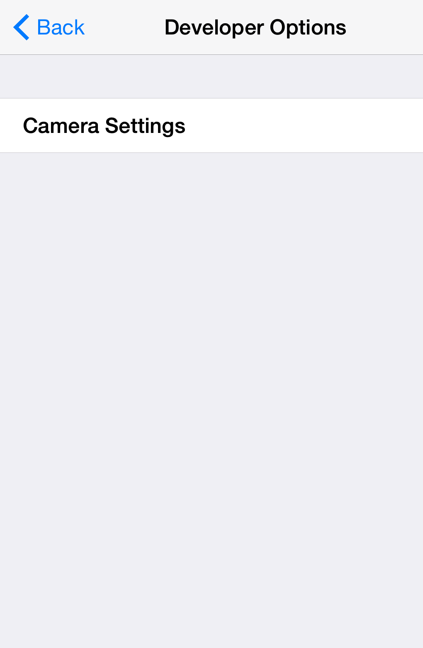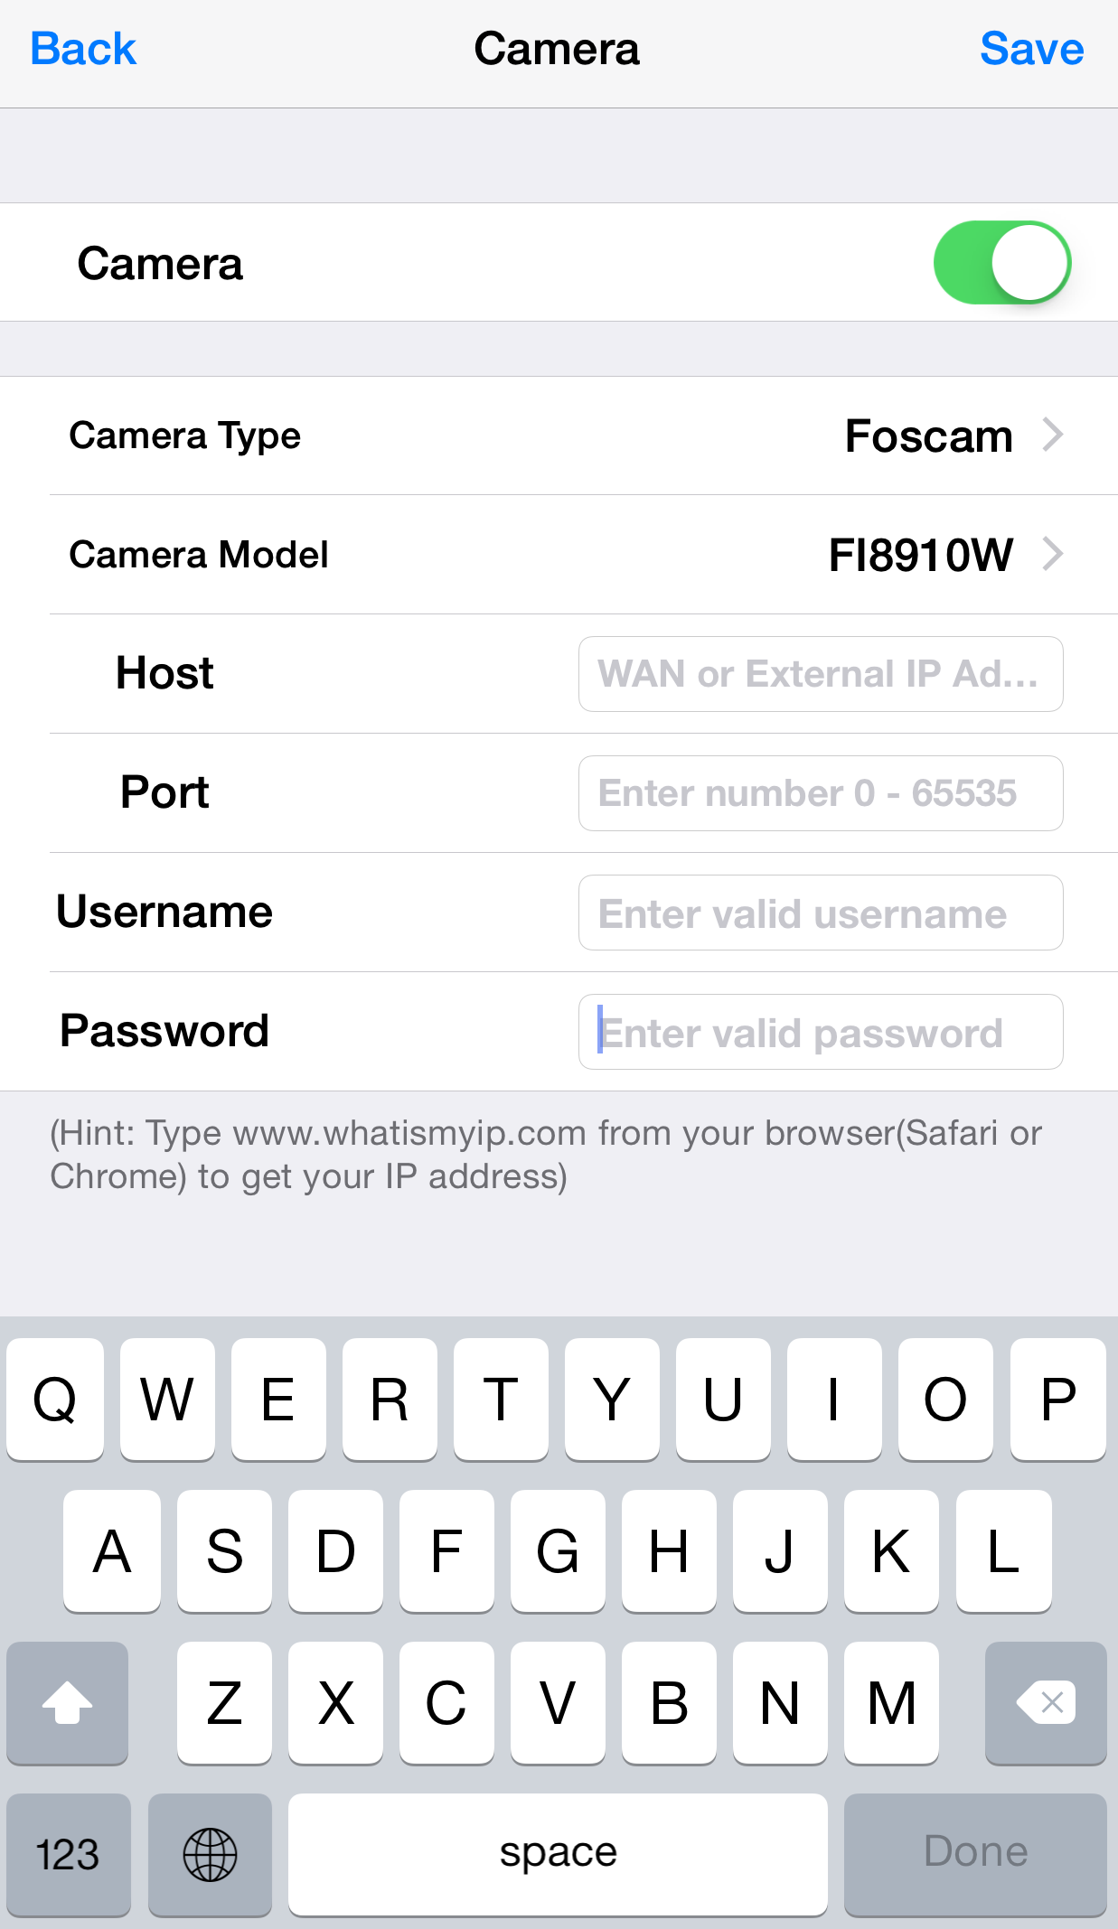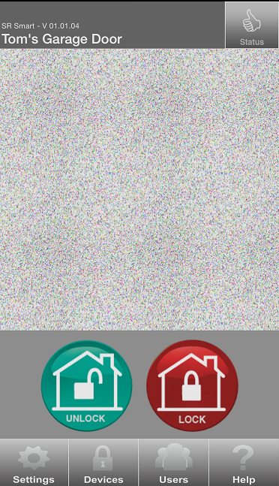

**Figure 146: Developer Options Screen** **Figure 147: Camera User Input** **Figure 148: SR App Home Screen**

# SR Portal

SecuRemote® Online allows users to expand the capabilities of SecuRemote Smart™. This web-based user management and authorization system lets the SecuRemote Smart™ Administrator use a computer to remotely manage users and their access times/days, and to monitor door use. SecuRemote® Online brings more convenience, control and security to families.

## Sign up for SR Portal

Go to <http://portal.securemote.com> and click on the “Create New Account” button to begin SecuRemote® Online. Refer Figure 149.

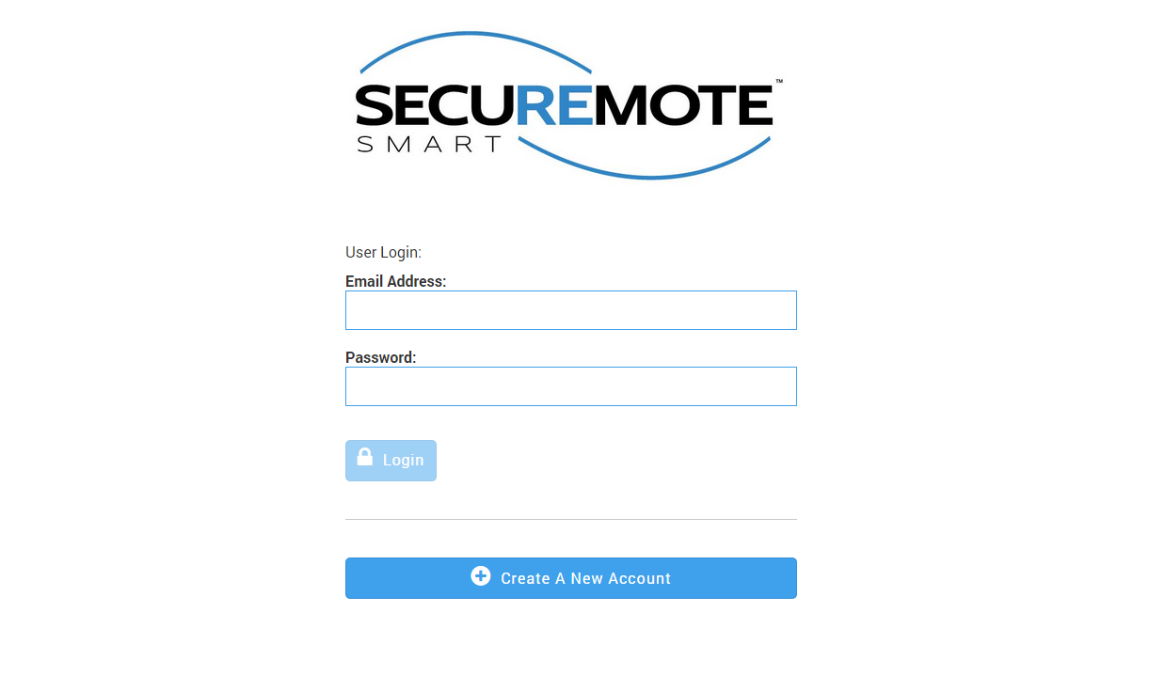

Figure 149: Sign Up

## New Customer Registration

The “New Customer Registration” screen appears. This screen collects basic login information about you and your SecuRemote Smart™ device as follows. Refer Figure 150.

* The E-mail address you enter is the username you will use to log-in again
* Passwords must be at least 6 characters long. There is no requirement for password complexity.
* Registration requires an “Email Address”, “Account Name” and “Password”. This information is stored for the account.
* Since devices may be installed in different geographical areas, it is important to know which time zone each device is in. This way schedules can be specified in local time for each device.

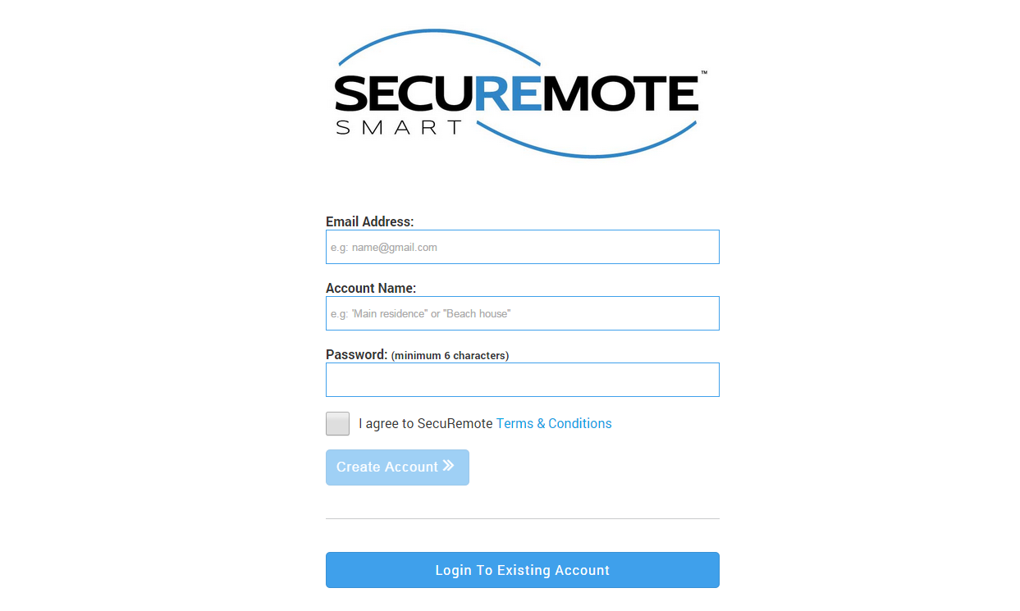

Figure 150: New Customer Registration

## Activate Your Account

Upon successful registration, the following screen appears and an e-mail entitled “Action required to activate your SecuRemote® Online service” is sent to you, with further instructions. Click (or copy and paste) on the link provided in the e-mail to verify ownership of the e-mail address. Refer Figure 151.

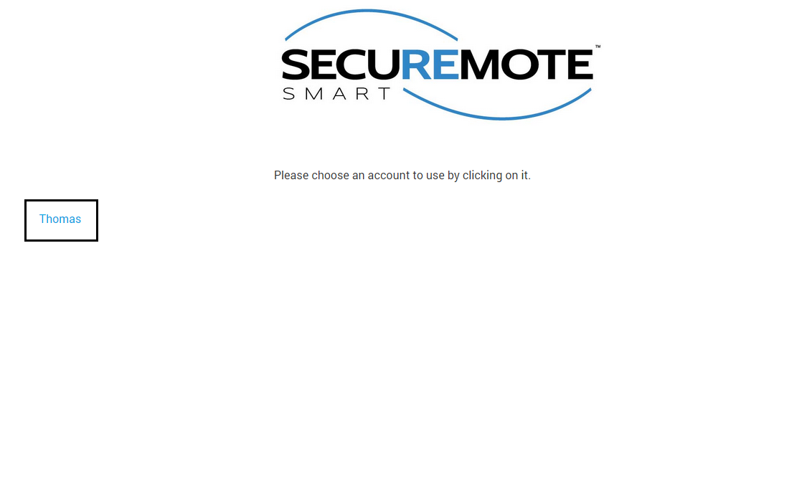

Figure 151: Registration Completed

## Sign-In Page

1. The e-mail address and password you used during registration are required to log-in to SecuRemote® Online. Your account must have been previously activated via the confirmation link sent to your e-mail.
   1. You can choose to have your password reset by following the “Forgot your Password?” This requires you to know the e-mail address and last name used to register the account. An e-mail Message is then sent to you with a link that can be used to complete the password reset. Refer Figure 152Figure 153

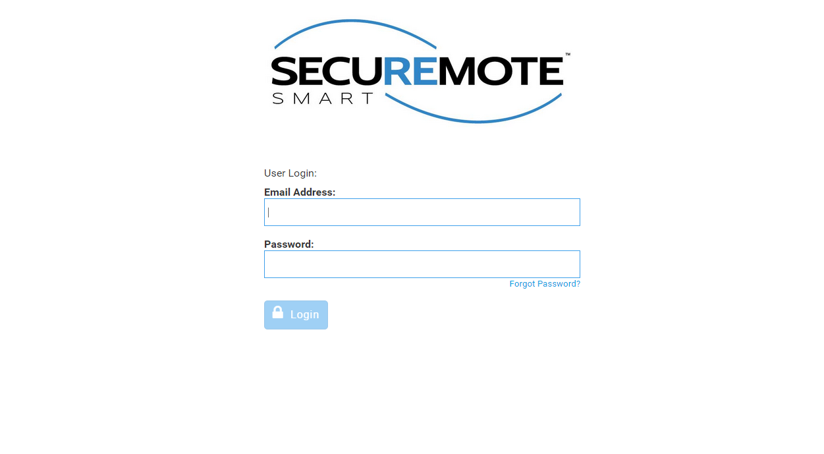

Figure 152: Sign In



Figure 153: Sign In

## Secure Home Page

Dashboard page will display with recent activities and welcome message. Refer Figure 154.

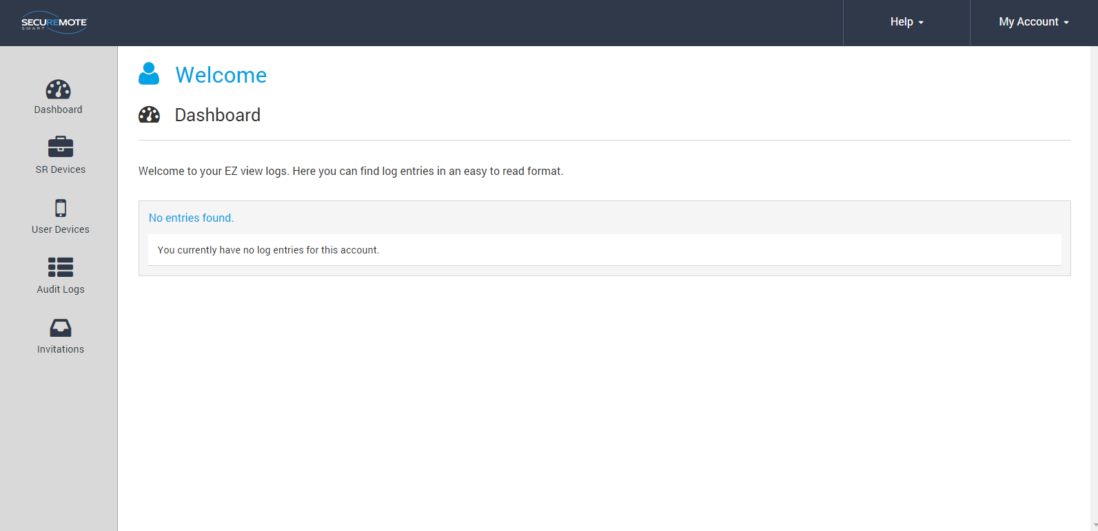

Figure 154: SecuRemote® Smart Home Page

## Register device

First user has to register the device from SecuRemote Smart™ Online site.

Select “SR Device” option and click on “Add SR Device”. Refer Figure 155.

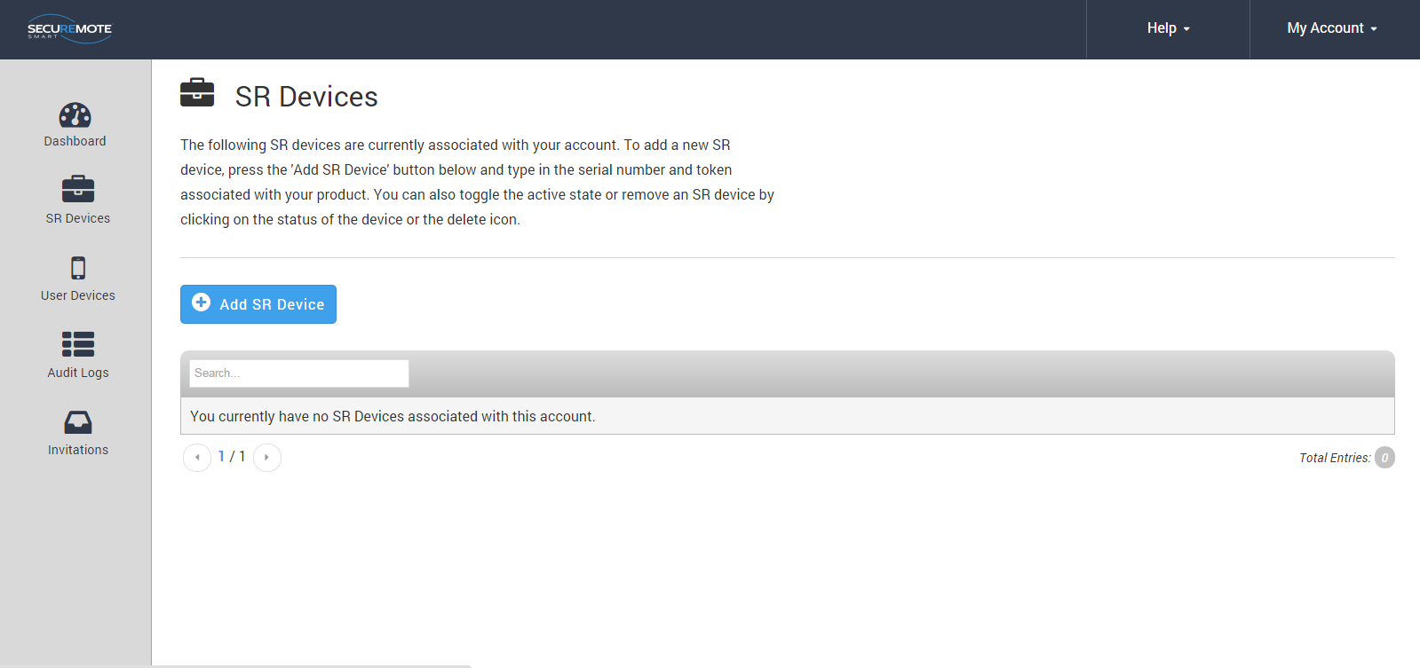

Figure 155: All devices

Requires entry of Serial number, Security token and Name of the SR GDO and click on “Add SR Device”. Refer Figure 156.

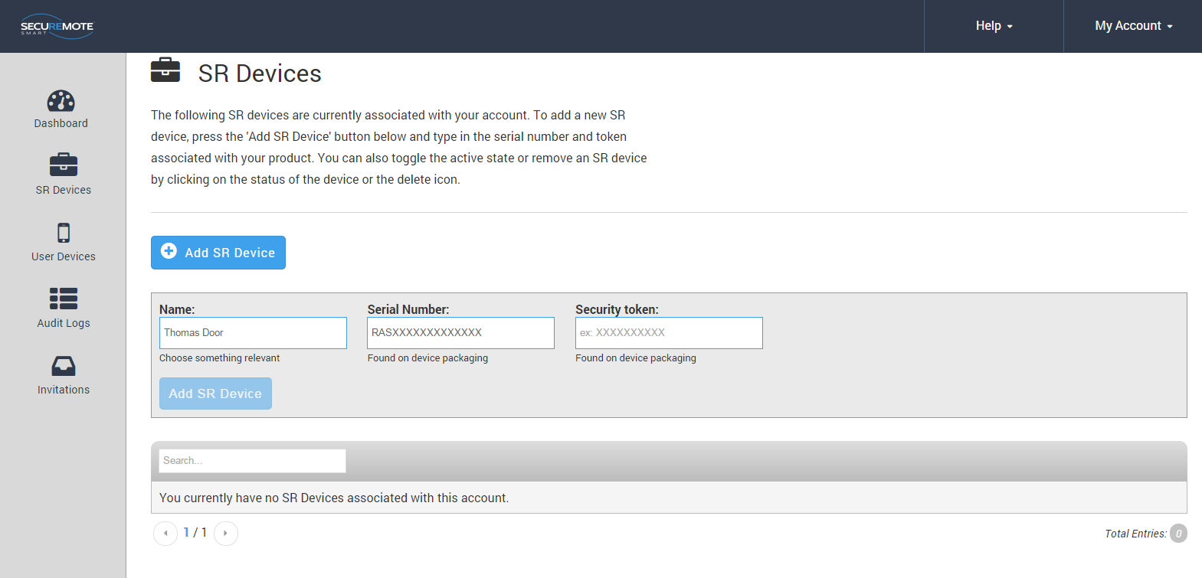

Figure 156: New device Registration

## All Devices

* 1. All devices belonging to the account are show in “SR Devices” screen.

Refer Figure 157.

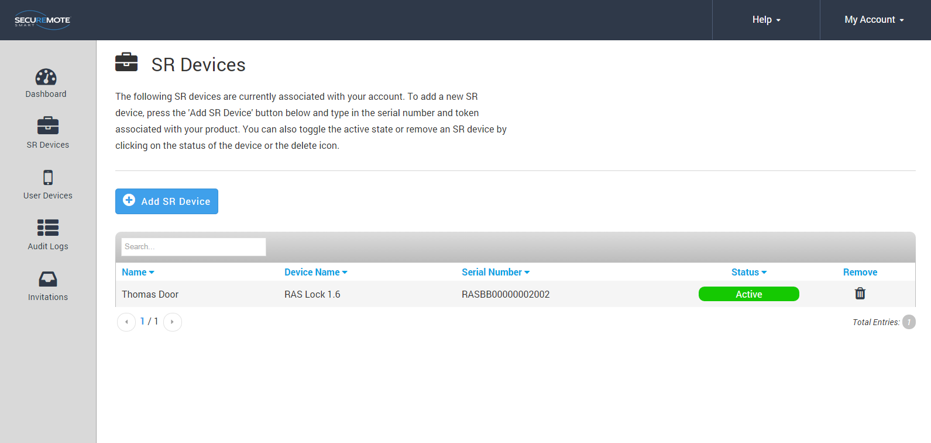

Figure 157: All devices

## 

## **Invite a New User Device**

Enter user name in the “Name” field and Click on “Request Invite Code”. You cannot enter a user with a name that already exist. Refer Figure 158

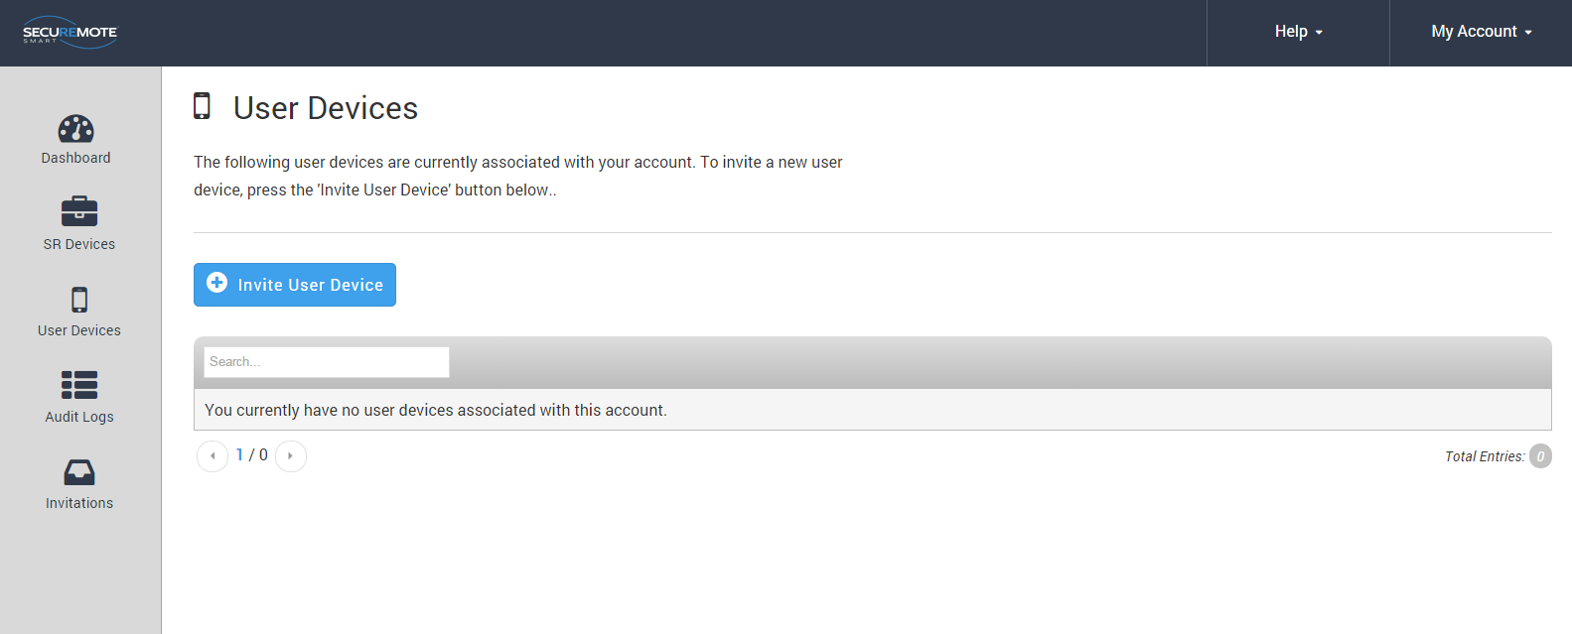

Figure 158: Invite a New User

New screen will show generated invited code and confirmation message will appear right hand bottom corner. Refer Figure 159.

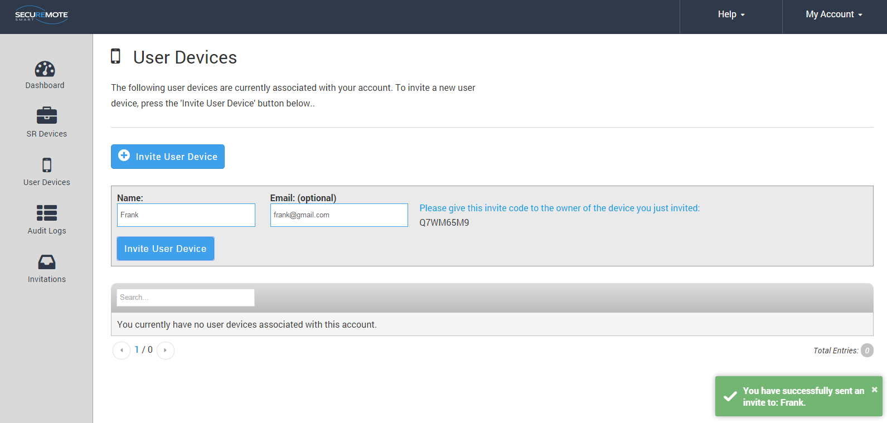

Figure 159: User Invitation

## **All Users**

1. The account administrator cannot be removed from the account.
2. Clicking on the user’s name brings up the “Edit user” dialog.
3. Security Link is an advanced security feature that allows the SecuRemote® Online service to uniquely identify a user’s smartphone. When a SecuRemote Smart™ app is run for the first time it generates a unique security token, a large random number that it sends to SecuRemote® Online every time an authorization request is made. This token must match the one used on previous requests in order for the request to be authorized. This ensures that no other smartphone can be used to initiate an authorization request on behalf of that user. Refer Figure 160.

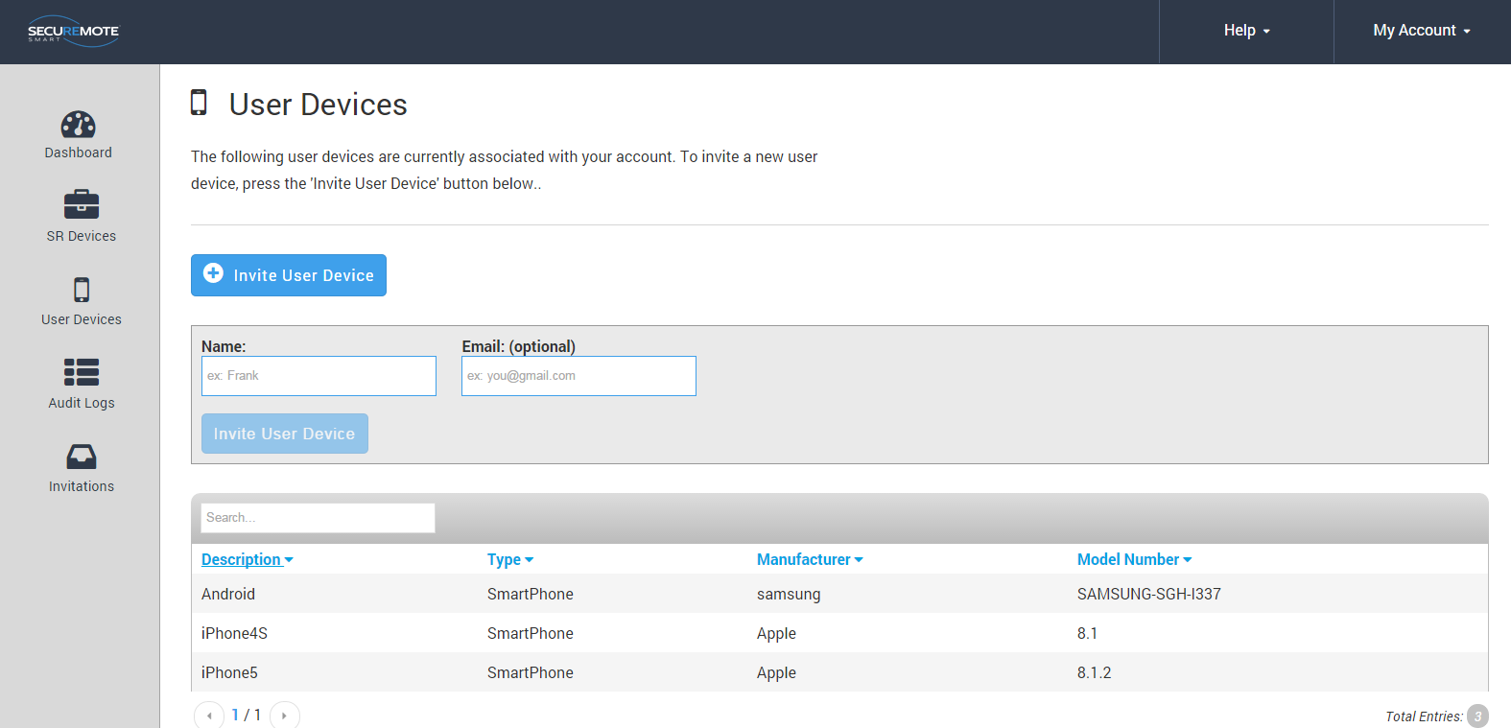

Figure 160: All Users

## **Audit Logs**

* 1. Audit log entries are shown in UTC by default on all accounts since it’s possible that they have multiple devices in different time zones.
  2. Audit logs are maintained for 365 days, the maximum length, by default for each account. The user can reduce this to as little as 7.
  3. Downloading the logs in Excel, CSV or XML format will download the entire audit log history. It is not affected by the filters used on the table above. Refer **Figure 161**.

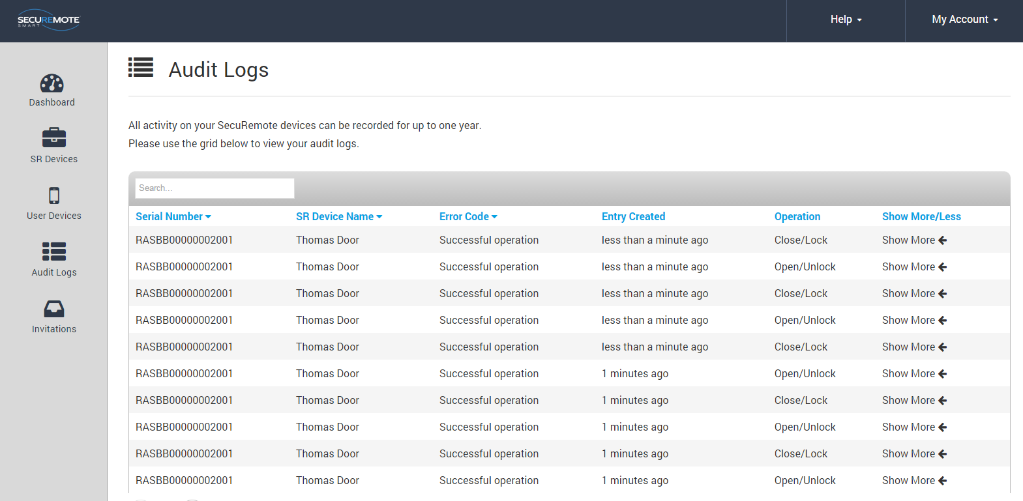

**Figure 161: Audit Logs**

## **Configure SR GDO for other SR Devices**

Click on manage to assign SR GDO to SR Device. Refer **Figure 162**.

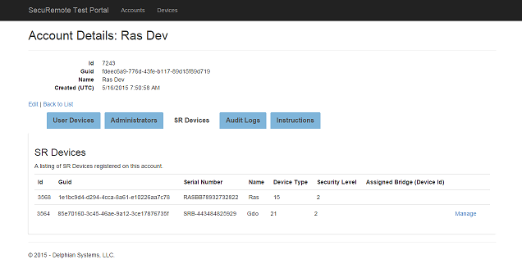

**Figure 162: Manage SR GDO**

Please tick on device check box which you want to Configure. Refer **Figure 163**

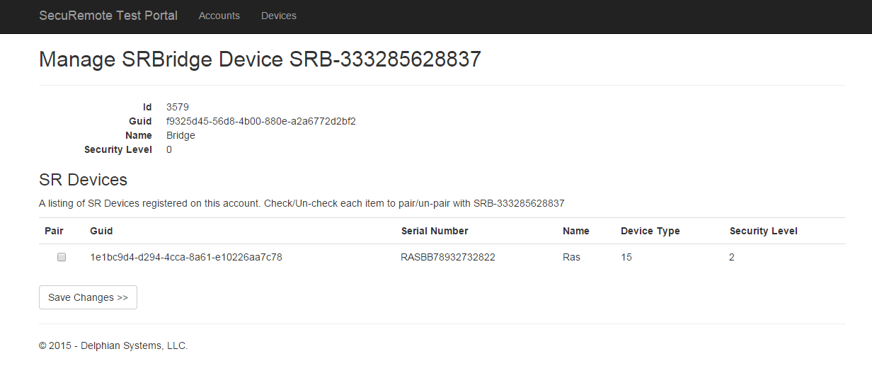

**Figure 163: Manage SR GDO**

Selected device’s ID will show on the RAS device’s Assigned Bridge. Refer **Figure 164**.

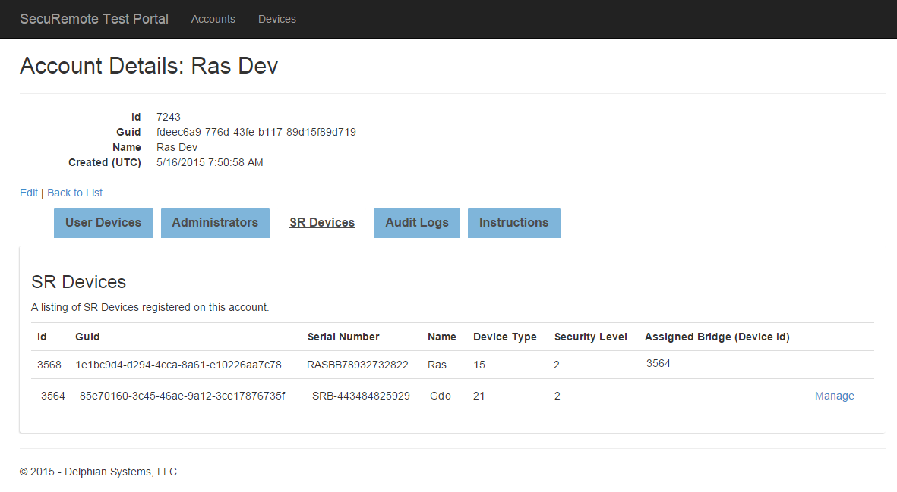

**Figure 164: Manage SR GDO**

## **Dashboard Option**

This screen shows recent activities. Refer **Figure 165**.

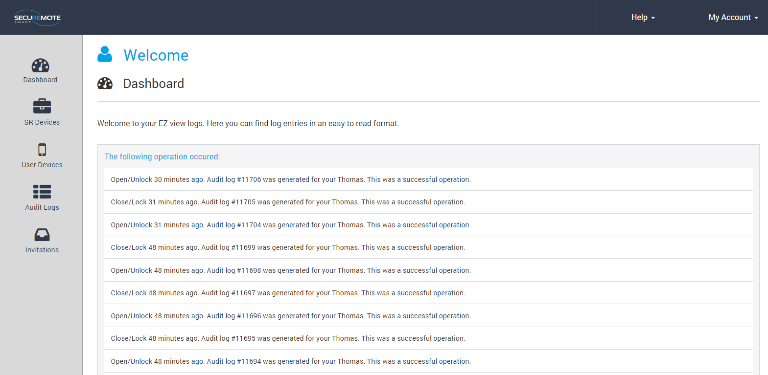

**Figure 165: Dashboard**

## **Invites Option**

This screen shows invitation send by users. Refer Figure 166.

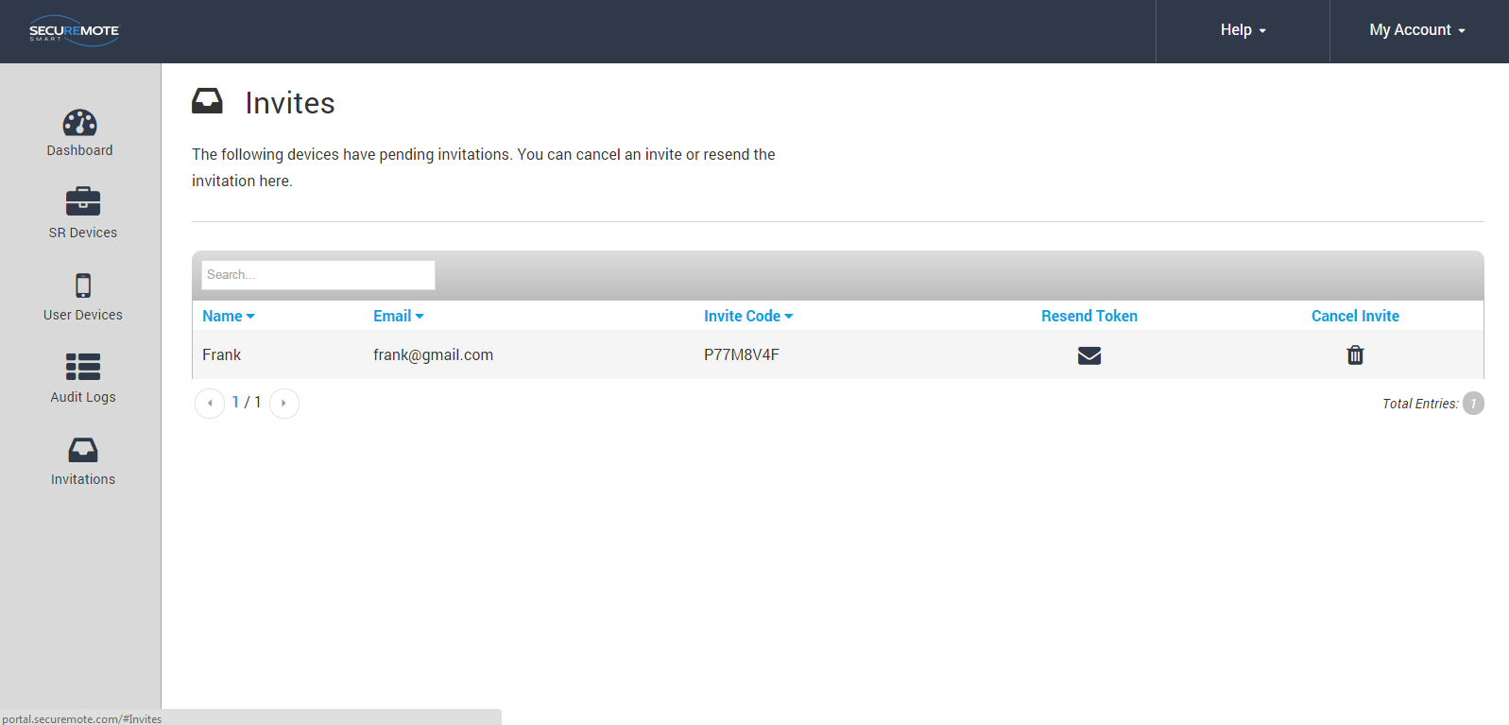

Figure 166: Invite Screen

# Remote Mode

This mode provide user to operate the device from remote location via internet connectivity.

User also has all the online mode features.

SR GDO comes with built in SR Bridge CDMA module. For SR GDO module user need to connect to power supply through adapter and it will automatically connect with register network. It will automatically enable remote operation once SR GDO gets internet connectivity.



## **Lock operation**

1. Click on “Lock” button from Home Screen. Refer Figure 167.
2. “Safety Warning Reminder” message appears with “YES/NO” option. Click on “YES” option. Refer Figure 168.
3. Request sent to SRO “Toast Message” will appear. Refer Figure 169.

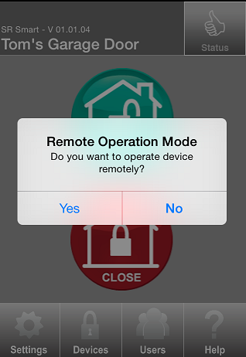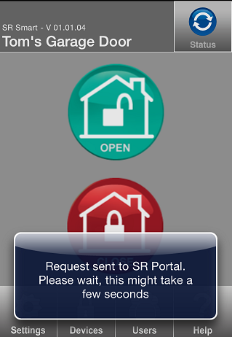

Figure 167: SR App Home Screen Figure 168: Safety Warning Message Figure 169: Request sent to SRO

1. “Lock” operation successfully performed message will appear. Refer Figure 170.
2. “Locked” status symbol will appear after the SR GDO is “Locked” successfully. Refer Figure 171

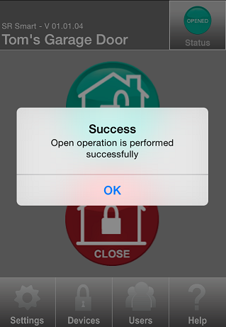

Figure 170: successfully Message Figure 171: successfully

## **Unlock operation**

1. Click on “UNLOCK” button from Home Screen. Refer Figure 172
2. “Safety Warning Reminder” message appears with “YES/NO” option. Click on “YES” option. Refer Figure 173.
3. Request sent to SRO “Toast Message” will appear. Refer Figure 174.



Figure 172: Home Screen Figure 173: Safety warning Message Figure 174: Toast Message

1. “Unlock” operation successfully performed message will appear. Refer Figure 175.
2. “Unlocked” status symbol will appear after the SR GDO is “Unlocked” successfully. Refer Figure 176

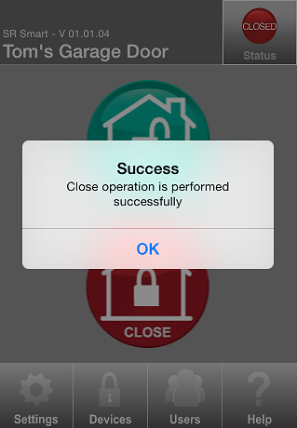

Figure 175: Success Message Figure 176: Status

## **Status operation**

1. Click on “STATUS” button from Home Screen. Refer **Figure** 177.
2. “Safety Warning Reminder” message appears with “YES/NO” option. Click on “YES” option. Refer **Figure** 178.
3. Request sent to SRO “Toast Message” will appear. Refer **Figure** 179.



Figure 177: Home Screen Figure 178: Safety warning Message Figure 179: Request sent to SRO

1. “Closed” status symbol will appear after the garage door is Closed successfully. Refer Figure 180.

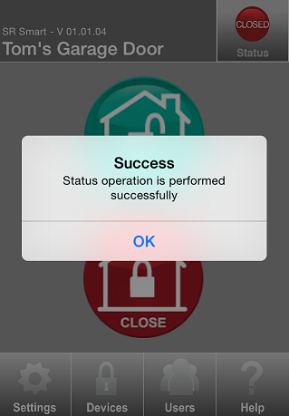

Figure 180: Success Message

1. If the door is opened then “Opened” will be indicated in Status. Refer Figure 181.
2. If the door is closed then “Closed” will be indicated in Status. Refer Figure 182.



Figure 181: Opened Status Figure 182: Closed Status

## **Remote Pairing**

Remote Pairing allows user to add SR device when it is not in Bluetooth range. User needs to enter invitation code to operate the device. The user can operate device only when device is added in SR Bridge. Remotely paired user cannot access settings of SR App.

To add user remotely follow the “Add User” steps.

# Update the SR Smart™ App

## Update the SR Smart™ App for iOS devices

Click on App Stores icon on your Home Screen. Click on “Updates” option in the bottom right corner. This will display any Apps that have updates available for your phone. To update the SR Smart App, select the SR Smart™ App and click on “Update” option in the upper right corner.

## Update the SR Smart™ App for Android devices

Update the SR Smart™ App by setting your Android up for automatic updates. Click on the Android Play Store icon from your Home Screen. Click on “SR Smart™” and select “Allow Automatic Updating”.

# Remove the SR SmartTM app from your Smartphone

**For iOS**

1. Tap and Hold on SR Smart App icon.
2. Click on Cross.
3. Message appears on screen with “Delete” and “Cancel” option.
4. Click on “Delete” option.

**For Android**

1. Go to phone “Settings”.
2. Click on “Application manager” option.
3. Select SR Smart app.
4. Click on Uninstall.
5. Message appears on screen with “Cancel” and “Uninstall” option.
6. Click on Uninstall.

# 

# Factory Reset

The user can set all parameters to Factory Reset default by pressing and holding the Factory Reset button for 5 seconds or more, located in the indoor unit of the SR GDO. The user will need to remove the cover to access this button.

Note: Manual factory reset will keep one audit log for the same and user will get that log when he/she pair with SR GDO first time after factory reset.

# SR GDO LED Indication

|  |  |  |  |  |  |
| --- | --- | --- | --- | --- | --- |
| SR.# | EVENT | LED1 | LED2 | LED3 | DESCRIPTION |
|  |  | Red | Blue | Green |  |
| 1 | Power On | B | B | B | All the LED Blink for 3 sec - 500 msec interval |
| 2 | Bluetooth Connection |  | B |  | Blue LED Blinking at 500 msec interval |
| 3 | No Cellular Network/Weak Signal | S | S |  | Red and Blue LED remain solid until Cellular Network resume |
| 4 | No Internet Connection - Signal Strength is Good |  | S |  | Blue LED remain solid until Internet connection resume |
| 5 | Internet Connection but No SRP Connection | B |  |  | Red LED will blink at 1 sec interval until device not register on SRP |
| 6 | SR Bridge/Device in not registered on SRP | B | S |  | Blink - 1 Sec |
| 7 | SRP Connected |  |  |  | All LED are OFF |
| 8 | Any Request Received |  |  | B | Green LED Blinking at 200 msec interval |
| 9 | Operation Request |  |  | B | Green LED Blinking at 200 msec interval |
| 10 | Operation Success |  |  | S | Green LED will Solid for 3 sec |
| 11 | Status |  |  | S | Green LED will Solid for 3 sec |
| 12 | Operation Fail | S |  |  | Red LED will Solid for 3 sec |
| 13 | Already Locked/Closed and Lock/Close request |  |  | S | Green LED will Solid for 3 sec |
| 14 | Already Unlocked/Opened and Unlock/Open request |  |  | S | Green LED will Solid for 3 sec |
| 15 | Async Event |  |  | S | Green LED will Solid for 3 sec |
| 16 | when 3rd time close operation failed for remote operation | S |  |  | Red LED will Solid for 5 sec |
| 17 | if failure case is running, no internet/cellular/SRP | S |  |  | Red LED will remain on for 3 sec and then network failure case will continue |
| 18 | if no internet/cellular/SRP and failure case | S |  |  | Red LED will remain on for 3 sec and then network failure case will continue |
| 19 | when garage is closed and magnetic switch is proper | B |  | S | Red LED will Blink for 3 times with 500 msec interval and Green LED will solide for 3 sec |

# 

# 

# Keyfob LED Indication

|  |  |  |  |  |  |
| --- | --- | --- | --- | --- | --- |
| SR.# | **EVENT** | **LED1** | **LED2** | **LED3** | **DESCRIPTION** |
|  |  | Red | Blue | Green |  |
| 1 | Keyfob Power ON. | B | B | B | Blink Red , Blue and Green simultaneously 1 time |
| 2 | Press and hold any key for more than 5 seconds. | B | B |  | Blink Red and Blue LED till connection with Smart phone or Configuration mode timeout (30 seconds) |
| 3 | connected with smart phone |  | B |  | Blue LED blinks continuously until disconnection from Smart phone |
| 4 | SR keyfob configured successfully |  |  | B | Blink Green LED three times |
| 5 | SR keyfob configuration failed | B |  |  | Red LED blinks twice |
| 6 | Press button to operate(open/close) |  |  | B | Green LED blinks until operation is completed |
| 7 | Out of bluetooth range | B |  | S | Green LED solid and Red blinks 4 times |
| 8 | Notification error | S |  | B | Red LED solid and Green blinks 4 times |
| 9 | Operation successful |  |  | S | Green LED solid for 2 seconds |
| 10 | User Not found |  | B |  | Blue LED blinks twice |
| 11 | Session ID mismatch | B |  | B | Red and Green LED blinks 3 times |
| 12 | Pairing FaiLED | B |  | B | Red and Green LED blinks 4 times |
| 13 | Operation timer expired | B |  | B | Red and Green LED blinks 5 times |
| 14 | Switch error in SR device | B |  | B | Red and Green LED blinks 6 times |
| 16 | Advertisement error | S |  |  | Red solid for 3 seconds |
| 17 | key not configured with any SR device | B |  |  | Red LED blinks 2 times |
| 18 | Error in connection | B |  |  | Red LED blinks 3 times |
| 19 | Low Battery indication | B |  |  | Red LED blinks 5 times |

# Frequently Ask Questions

1. I am not able to Pair with an SR device in Local Mode. What should I do?
2. Make sure your smartphone Bluetooth is turned ON, the SR device is powered ON, and that both devices are within direct operation range.
3. Turn OFF Bluetooth of your smartphone and Turn ON again.
4. How do I set Administrative PIN?

User can change Administrative PIN any time.

1. Launch SR Smart App.
2. Select “Settings” -> “SR App Settings”.
3. Click “Set Admin PIN”.
4. Enter current Administrative PIN when prompted.
5. Enter your new Administrative PIN, Confirm Administrative PIN and press “SAVE” button.
6. How can I set User PIN?

User can change User PIN any time.

1. Launch SR Smart App.
2. Select “Settings” -> “SR App Settings”.
3. Click “User PIN”.
4. Enter current Administrative PIN when prompted.
5. Enter your new User PIN, Confirm User PIN and press “SAVE” button.
6. How do I add SR devices?

Make sure your smartphone Bluetooth is turned ON, the SR device is powered ON, Mobile Data is turned ON and that both devices are within direct operation range.

1. Go to the SR App “Devices” menu.
2. Click on “Add devices” option.
3. Click on “Scan QR Code” or Enter SR# manually.
4. Fill Mandatory information and click on “Create New Account”.
5. Enter Email ID, Password, “User Name” and click on “Register SR Device” button.
6. How can I operate an SR device within SR Device range?
7. Make sure your smartphone Bluetooth is turned ON, the SR device is powered ON, and that both devices are within direct operation range.
8. Verify that you have successfully paired with the SR device and that the device you want to operate is shown on the upper left of SR Smart App home screen, if not the select it from the “Devices” menu.
9. Press any of the operation buttons shown on the SR Smart App home screen.
10. Cannot able to operate an SR device within SR Device range, what do I do?
11. Make sure your smartphone Bluetooth is turned ON, the SR device is powered ON, and that both devices are within direct operation range.
12. Turn your smartphone Bluetooth OFF and ON again.
13. If you are not an authorized User, please contact the Administrator of that device for more information.
14. How do I check the device status?
15. Make sure your smartphone Bluetooth is turned ON, the SR device is powered ON, and that both devices are within direct operation range.
16. Launch the SR Smart App and press “Status” button at the right-top corner of the SR Smart App home screen.
17. How to switch between SR devices?
18. Launch the SR Smart App and go to the “Devices” menu.
19. Select the SR device from the device list.
20. How can I rename an SR device?
21. Go to the SR Smart App “Settings” menu.
22. Click on “SR Device Settings” menu.
23. Click on “Device Name”.
24. Enter new name of device and then press “Save” button.
25. How can I delete an SR device?

Make sure your smartphone Mobile Data is turned ON.

1. Go to the SR Smart App “Settings” menu.
2. Press the “Delete SR Devices” option.
3. Press “Yes” button from “Removing SR Device” message.
4. How can I add a new user?

Make sure your smartphone Mobile Data is turned ON.

1. Go to “Users” option of the SR Smart App.
2. Enter current Administrative PIN when prompted.
3. Click on “Invite Access Device” option.
4. Enter Email ID, password when prompted and click on “Validate Details” option.
5. You can add a user by using any of the following options:

* Select from Contacts: You can select contact from Phone book directly.
* Type In: You will need to enter user information manually.

1. Click on “Get Invite Code” option.
2. You will be asked to send an SMS to the user. If you want to inform this user that he/she is authorized to operate this device and prompt them to download the SR Smart App from the embedded link press “YES” otherwise press “NO” button. Note: This option is available only on cellular enabled devices. Standard SMS messaging rates may apply.

* Type In: You will need to enter user information manually.

1. Click on “Get Invite Code” option.
2. You will be asked to send an SMS to the user. If you want to inform this user that he/she is authorized to operate this device and prompt them to download the SR Smart App from the embedded link press “YES” otherwise press “NO” button. Note: This option is available only on cellular enabled devices. Standard SMS messaging rates may apply.
3. How to delete user SR App?

Make sure your smartphone Mobile Data is turned ON.

1. Go to “Users” menu of the SR App and select the user from the user list.
2. Click on “Delete Access Device” option.
3. Enter Email ID, Password when prompted and click on “Validate Details” option.
4. Use will be deleted.
5. How do I add a user using the SR App?

Log in to your existing SRO account by visiting [https://www.securemoteonline.com](https://www.securemoteonline.com/). If you have not created an SRO account yet, please register by visiting <https://www.securemoteonline.com/Account/Register>.

1. Go to “User Devices” option from SR Portal.
2. Click on “Invite User Device” and manually fill the information and click on “Invite User Device”
3. “Invite Code” will display on SR Portal.
4. What does “Accept Invitation” mean?

In order for a new user to operate a device that the Administrator has authorized them, the user must first accept the invitation sent to them via email or SMS. The invitation Message also contains the Invitation Code, a 7-digit code, that the user will be prompted to enter upon setting up the SR App or attempting to pair with the SR device that has been authorized to operate.

1. Why the SR App is unable to operate an SR device from SRO?

Make sure you have Internet Connectivity and that your SR device and SR Bridge are powered ON.

1. How do I get status of SR device at remote location?

Press the “Status” button shown at the right-top corner of the SR App home screen.

1. What if “You forgot to close the door” notification receive by user?

Notification alert which is triggered if you have forget to close Garage door and moved a mile away from the SR device location. This is accomplished by SR tracking both the SR device status and your approximate location by using your Smartphone's Location Services.

1. How do I enable notification if I forgot to close the door?

Once you have registered an SR Bridge with SRO, the SR App will automatically detect the SR Bridge and it will enable this notification functionality for SR devices that support it (SR Locks and Garage Door devices) provided that you have enabled your Smartphone’s Location Services and have authorized the SR App to use them.

**For iPhone:**

1. Make sure you have enabled Location Services and had given permission to the SR App.
2. You can enable Location Services using iOS Settings>Privacy>Location Services.

**For Android:**

1. Make sure you have enabled GPS/Network Provider Enabled.
2. You can enable GPS/Network Provider using Settings>Location Services.

**To mark the SR device location:**

1. If you want to manually enable the “Doors Unintentionally Left Open or Unlocked” notification, go to Settings> Security Settings>SR Gateway.
2. Press “Set Location” and make sure you are within range of the SR device.
3. How accurate and reliable is the “Doors Unintentionally Left open or unlocked” notification?

The accuracy of your location depends on the type of Location Services used by your Smartphone and the speed at which you are moving away from your home/office (SR device location). When a door is left open/unlocked SRO will request your location from the SR App and will trigger the notification alert once your physical distance has exceeded

a mile from the device. Your exact physical distance at the time the notification alert Message is shown on your Smartphone screen will depend on the GPS connectivity and speed at which you are driving away - it will typically be about a mile. For iPhone users, please make sure you keep your Wi-Fi always ON. For more accurate results iPhone will use public Wi-Fi networks to calculate your current location. The notification is very reliable as long as your Smartphone Location Services are enabled and the SR devices are powered ON.

1. “Two consecutive operation fails operate device locally” what user should do if this message display?

If user fails to operate SR GDO in remote mode for two times back to back than user needs to operate SR GDO locally for safety reasons. After operate SR GDO locally than only user can allow to operate SR GDO in remote mode again.

1. I am the Administrator and have lost my phone. How do I set my new phone as Administrator to the SecuRemote® device?

Do a factory reset of the SecuRemote® device by pushing and holding the reset button using a paper clip until blue light starts to flash, then release the button. This will delete all direct users from the SecuRemote® device and reset the Administrator password and save the Bluetooth® PIN as “1234”. Download and install the SecuRemote® App to the smartphone. Start the App and finish pairing with the SecuRemote® device. This will establish the new phone as the administrator again. The User needs to re-enter all direct users to the SecuRemote® device again. As the SecuRemote® device is defaulted to factory re-set, all direct and online users need to pair with the SecuRemote® device using the pairing option.

1. One of the direct users lost his/her phone. How do I delete direct user from SecuRemote® Device so this phone cannot access the device anymore?

Any direct user with unlimited privilege can delete this user from the SecuRemote® device using delete option under user list. This is verified through the Administrator password so the user needs to know the Administrator password.

1. A user forgot the Administrator password and how do I reset it?

User needs to delete the SR App and install new app and user default password”1234 ”.

1. I received an error for “maximum allowable users are added” when trying to add new user.

SecuRemote® allows a maximum of 10 users including the Administrator. If the Administrator wants to add a new user, the Administrator needs to delete any existing user or edit any existing user with the new user information.

1. My iPhone® shows that the Bluetooth® is connected but the SecuRemote® device shows that the device is not connected.

This is an issue with the Bluetooth® functionality of your iPhone®. Turn the Bluetooth® off and then on from the Bluetooth® from the Bluetooth® setting screen. Now try to re-connect your Bluetooth®. Please refer to your smartphone user manual for further information.

1. How to activate GPS/Location Services in Smartphone?

iOS:- Settings-Privacy Location services SecuRemote®

Android: - Settings◊Location Services◊Enable Use GPS satellites

1. How family member can inherit admin access?

When any family member will Scan QR Code and add device in his smartphone then family member can inherit Admin access.

1. What is the meaning of pre operation warning?

When user close GDO in remote mode for safety reasons pre operation warning of light blink and buzzer will play for six seconds before performing close operation.